

Performance Test Results

Translink

Trapeze Conventional Upgrade Performance Test Results

Trip Planner (September 19th-21st)

Date: April 24, 2019

This report provides a summary of the results of performance tests conducted in the Trapeze Staging environment for Translink

Prepared by:

Chris Flint

Professional Quality Assurance Ltd.

# Executive Summary

PQA conducted several rounds of performance testing against Translink’s Trapeze Trip Planning implementation. The purpose of the testing was to determine whether the Trip Planning Service, as implemented, can sustain the typical load levels for normal and peak day-to-day operations.

The scope of the testing involved the use of an existing script that simulated the user activity over the course of a half-hour. The average user session lasted approximately 2 minutes, and involved typical trip planner usage (opening the trip planner page, searching for an origin and a destination, and reviewing returned results). Historical usage stats are found below – this is expressed in terms of users/hour. The tests spread the individual users out evenly across the run times:

|  |  |
| --- | --- |
| Trip Planner historical peak | 4000 users/hour |
| Trip Planner typical hour | 1400-1500 users/hour |

Measurements of the response times and throughput captured during the testing were the primary metrics used to evaluate the service. Also of interest were the server resource usage statistics – comprising CPU use, memory use, network bandwidth, and disk R/W operations.

*High Level Results*

For the Trip Planner, there are 5 defined load scenarios, covered by 13 total test runs. The scenarios are:

* A historical peak test (1 run)
* Incremental increase to failure test (4 runs; increasing load per run)
* A spike test (1 run)
* A future capacity test (6 runs; increasing load per run)
* An endurance/stress test (1 run)

There are 10 servers currently set up in the beta environment; all runs were conducted against the load balancer, with the expectation that all servers would be exercised in the course of the testing.

In general, transaction times were good under typical day-to-day conditions, with a few slowdowns under heavier loads. In terms of overall results, our transaction breakdown looked like:

|  |  |
| --- | --- |
| *Transaction* | *Average Response Times* |
| Open Trip Planner page | ~1.5 secs |
| Enter Origin (and get results back) | ~0.6 secs |
| Enter Destination (and get results back) | ~0.6 secs |
| Submit (by selecting locations from the returned origin and destination) | ~2.3 secs |
| Retrieve Individual Itineraries (if any were found between the origin and destination) | ~0.6 secs |

These should be fairly close to what we would expect an end-user to see, bearing in mind that their browsers will take slightly longer to “paint” the window (filling in the map, drawing itineraries, et cetera).

The server resource usage looked like the following:

|  |  |  |
| --- | --- | --- |
| *Resource Statistic* | *Moderate Load* | *High Load (Peaks)* |
| CPU Usage | ~11% | ~40.6% |
| Memory Usage | ~18.9% | ~39.1% |
| Network Data Receive Rate | ~54 KBps | ~4,957.6 KBps |
| Network Data Transmit Rate | ~650 KBps | ~1,877.8 KBps |
| Virtual Disk Read Throughput | ~0.1 KBps | ~5,105.8 KBps |
| Virtual Disk Write Throughput | ~50 KBps | ~22,781.3 KBps |

The CPU and Memory usage look particularly healthy, with none of the issues that appeared in QA reappearing here.

*Potential Issues Encountered*

While the averages above are useful for getting a broad sense of the majority of users’ experience, occasionally, the service would end up resetting the sockets – this most often corresponded with a server reboot (the service has scheduled reboots to mitigate the effects of an existing memory leak). An end-user would likely experience this as a “server disconnection”. The error rates rarely exceeded 0.8% for a given transaction.

# Testing Summary and Results

Performance Testing Methodology

5 Performance testing scenarios have been devised to realistically simulate users working with the Trip Planner site. These scenarios are intended to exercise the environment in order to determine the overall behavior and any thresholds for peak and maximum capacity.

All scenarios will use scripts developed with Apache JMeter (an open-source performance testing tool).

Detailed descriptions of the Trip Planner load scenarios can be found below, alongside parameters for expected virtual users (derived from the test requirements) and test durations. In many cases, the expected users are listed as “users per hour” at the load balancer, that is, for the whole system. When the scenarios are run, the expected user counts are adapted to a concurrent user count – the test results further below will have precise numbers.

Test Scenarios

**Scenario 1: Trip Planner Historical Peak**

* Navigate to the Trip Planner page
* Enter an origin location
* Enter a destination location
* Submit the two locations in a request to generate trip plans

*Expected Users*: Equivalent to 4000 users/hour at the load balancer

*Duration*: 30 minutes with 5-minute ramp-up

*Environment*: tripplanning-beta.translink.ca

*Key Performance Metrics*: response time, concurrent users, server resource utilization (CPU, Memory)

**Scenario 2: Trip Planner Incremental Increase to Failure**

* This is several runs at increasing load levels to attempt to determine where the user error rate or transaction response time is over the acceptable level.

*Expected Users*: 200 -> 250 -> 300 -> 400 concurrent users

*Duration*: 30 minutes with 5-minute ramp-up per run

*Environment*: tripplanning-beta.translink.ca

*Key Performance Metrics*: response time, concurrent users, server resource utilization (CPU, Memory)

**Scenario 3: Trip Planner Spike Test**

* A very high load sustained over several hours to simulate days with high demand (like a snow day)

*Expected Users*: 5000 per hour

*Duration*: 4 hours with 5-minute ramp-up

*Environment*: tripplanning-beta.translink.ca

*Key Performance Metrics*: response time, concurrent users, server resource utilization (CPU, Memory)

**Scenario 4: Trip Planner Future Capacity**

* This explores whether the system has the capacity to cover several years of expected growth, in order to determine when future upgrades may be needed

*Expected Users*: Start from a typical user load, and complete 5 more runs, increasing by 10% each time

*Duration*: 30 minutes with 5-minute ramp-up per run

*Environment*: tripplanning-beta.translink.ca

*Key Performance Metrics*: response time, concurrent users, server resource utilization (CPU, Memory)

**Scenario 5: Trip Planner Endurance Test**

* A long run to see how the servers perform under lengthy periods of stress

*Expected Users*: 5000 per hour

*Duration*: 24 hours

*Environment*: tripplanning-beta.translink.ca

*Key Performance Metrics*: response time, concurrent users, server resource utilization (CPU, Memory)

Special Scenarios

In addition to the traditional server performance testing against the Trip Planning implementation, there were also several front-end scenarios of interest. In particular, there were 11 scenarios that needed to be executed against the Trip Planner and the OPS Web services.

This involved the reuse of several Selenium/WebDriver scripts that JMeter could execute automatically, using the Chrome Driver to run a Chrome browser instance, in order to simulate what an actual user would experience. The tables below provide a summary of the scenarios in question, their expected results, the actual results, and a pass/fail.

|  |  |  |  |  |  |  |  |  |
| --- | --- | --- | --- | --- | --- | --- | --- | --- |
| ***Trip Planner Scenarios*** | | | | | | | | |
| **Departing From** | **Going To** | **Arriving/Departing** | **Time** | **Date** | **Options** | **Expected Results** | **Actual Results** | **Pass/Fail** |
| Marine and Capilano | Georgia and Burrard | Arriving | 6:00 AM | Sunday Date | Accept Defaults | *Cannot match parameters*: Time out at 20 seconds and error message displayed | Time out after 30 seconds; error message displayed | **Tentative**  **Pass** (System timeouts seem to be 30 secs, not 20) |
| Granville and Davie | Waterfront Station | Arriving | 5:00 PM | Today’s Date | Allow more Transfers | *Too many possible layouts*: Time out at 30 seconds and error message displayed | Time out after 30 seconds; error message displayed | **Pass** |
| Granville and Davie | Waterfront Station | Arriving | 5:00 PM | Today’s Date | Accept Defaults | Response within 12 seconds | Response returned after 31 seconds | **Fail** |
| Lonsdale and 29 | Steveston Village | Arriving | 12:00 PM | Today’s Date | Accept Defaults | Response within 12 seconds | Response returned within 12 seconds | **Pass** |
| 22nd Street Station | 29th Avenue Station | Arriving | 12:00 PM | Today’s Date | Accept Defaults | *Vanilla Trip*: Response within 5 seconds  *Rerun data set*: Response within 1 second  *Rerun data set, plus select “View Detail”*: Response within 2 seconds | *Vanilla Trip*: Response returned within 5 seconds  *Rerun*: Response returned within 1 second  *View Detail*: Response returned within 2 seconds | **Pass** |
| Burrard and Robson | Hamilton and Pender | Arriving | 12:00 PM | Today’s Date | Requires Wheelchair Access | *Wheelchair accessible with many layout possibilities*: Response within 20 seconds | Response returned after 30 seconds | **Fail** |
| Newton Exchange | Coquitlam Central Station | Arriving | 12:00 PM | Today’s Date | Allow More Transfers | *Involves 4 or more legs, with allow more transfers*: Response within 13 seconds | Response returned within 13 seconds | **Pass** |
| Newton Exchange | Coquitlam Central Station | Arriving | 12:00 PM | Today’s Date | Accept Default | *Involves 4 legs*: Response within 10 seconds | Response returned within 10 seconds | **Pass** |
| Waterfront Station | Scott Exchange | Arriving | 12:00 PM | Today’s Date | Get Lines and Stops for Origin only  De-select all  Re-select 014EAST | Response under 1 second  Subsequent runs should be under 1 second | These options are not available in the new Trip Planner, so this test was not run | **N/A** |

|  |  |  |  |  |
| --- | --- | --- | --- | --- |
| ***Next Bus Scenarios*** | | | | |
| **Scenario** | **Steps** | **Expected Results** | **Actual Results** | **Pass/Fail** |
| Schedule Lookup | Look up the schedule for the 116 bus route plan.  Steps:   1. Enter tripplanning-beta.translink.ca into browser 2. Enter “116” in Enter Location field 3. Select “116 EDMONDS STN/METROTOWN STN EAST” from the dropdown menu | Response under 1 second | Response returned under 1 second | **Pass** |
| Next Bus at Stop | Look up the next bus for a bus stop # 52707  Steps:   1. Enter tripplanning-beta.translink.ca into browser 2. Enter 52707 in the Enter Location field. 3. Select “52707 EB NORTH FRASER WAY AT 3700 BLOCK” from the dropdown menu | Response under 1 second | Response returned under 1 second | **Pass** |
| Find Nearby Stops | Look up nearby stops without using the bus stop number  Steps:   1. Enter tripplanning-beta.translink.ca into browser 2. Enter “Marine Way and Boundary” in the Enter Location field 3. Select “MARINE WAY @ BOUNDARY RD, VANCOUVER” from the drop down. | Response under 1 second | Response returned under 1 second | **Pass** |

|  |  |  |  |  |
| --- | --- | --- | --- | --- |
| ***OPS Web Scenarios*** | | | | |
| **Scenario** | **Steps** | **Expected Results** | **Actual Results** | **Pass/Fail** |
| Driver Login | User signs in  Steps:   1. Enter <http://trpopsappp001:9005/hiwire?.a=opHome>   into browser   1. Enter Badge Number: 1609 PIN: 1609 2. Click Login button | Less than 2 seconds | User logged in under 2 seconds | **Pass** |
| Driver Paddle | User opens the Paddle  Steps:   1. Enter <http://trpopsappp001:9005/hiwire?.a=opHome>   into browser   1. Enter Badge Number: 1609 PIN: 1609 2. Click Login button 3. Select Assignment Calendar from Daily Assignments menu 4. Select June from month drop down 5. Select 2018 from year drop down 6. Click on search button 7. Click a paddle icon in the calendar | Less than 24 seconds | Driver Paddle returned under 24 seconds | **Pass** |

Test Results

Here can be found the performance testing results. All scenarios executed with JMeter have measured transaction statistics, as well as the following graphs:

JMeter Graphs:

* Running Users – displays the number of active virtual users during the script execution. Intended to give a sense of the user load at any given point.
* Hits per Second – displays the number of hits on the server during each second of the test. Intended to give a sense of how active a user is at any given second.
* Transactions per Second – displays the number of completed transactions during each second of the test (successful or unsuccessful). Intended to give a sense of the actual transactional load on the system at any given point
* Average Transaction Response Time – displays the average time take to get a response from the server during the load test. Intended to approximate the end-user experience as load is applied to the service. If a transaction runs notably slower than the others, then a second graph is given with just the “fast” transactions.

All JMeter graphs have a granularity of 1 minute, which provides a smoother curve and has the advantage of being easier to read.

We also have a set of server graphs, covering the below stats for each server across the whole testing period.

Server Graphs:

* CPU Usage (%)
* Memory Usage (%)
* Network Data Receive Rate (KBps)
* Network Data Transmit Rate (KBps)
* Virtual Disk Read Throughput (KBps)
* Virtual Disk Write Throughput (KBps)

**Scenario 1 – Trip Planner Historical Peak**

Scope: This run was completed to determine whether the service can handle a load equivalent to the most recent peak in usage. The previous production peak of 4000 users/hour was applied directly to the system.

Tool: JMeter

JMeter Setup: 90 users, 5-minute ramp-up, Loop “Forever”, Scheduler Enabled, Scheduler Duration 1800 seconds (0.5 hours)

Server: tripplanning-beta.translink.ca

Start Time: 2019-Sep-20 09:23 AM (PDT)

End Time: 2019-Sep-20 09:53 AM (PDT)

Notes: The service looks to perform well at this level of load. The Submit transaction might be a point of concern, as 5% of users would likely see response times of 5 seconds or more, and 1% of users would likely see response times of 12 seconds or more.

Running Users

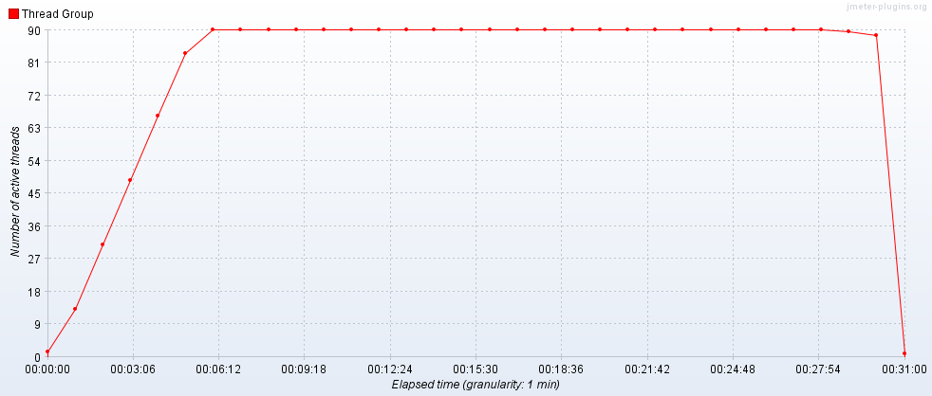

Hits per Second

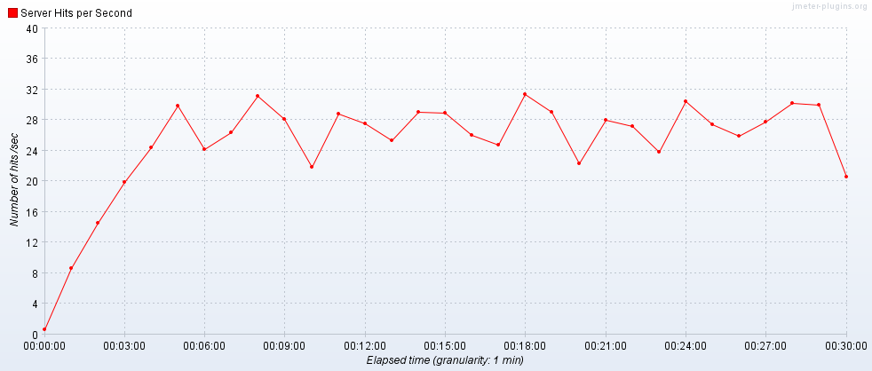

Transactions per Second

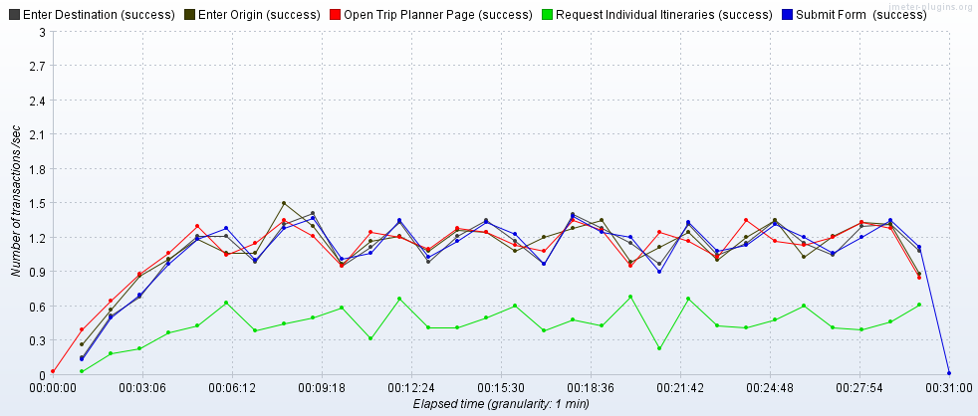

Transaction Statistics

|  |  |  |  |  |  |  |  |  |  |  |  |  |
| --- | --- | --- | --- | --- | --- | --- | --- | --- | --- | --- | --- | --- |
| Label | # Samples | Average | Median | 90% Line | 95% Line | 99% Line | Min | Max | Error % | Throughput | Received KB/sec | Sent KB/sec |
| Open Trip Planner Page | 2021 | 1412 | 1374 | 1727 | 1870 | 2293 | 891 | 5122 | 0.00% | 1.12361 | 4914.89 | 37.69 |
| Enter Origin | 2003 | 584 | 560 | 791 | 940 | 1483 | 89 | 2133 | 0.00% | 1.1252 | 5.04 | 0.51 |
| Enter Destination | 1989 | 573 | 557 | 780 | 943 | 1412 | 93 | 2146 | 0.00% | 1.12788 | 5.11 | 0.52 |
| Submit | 1988 | 1924 | 239 | 4495 | 5277 | 12663 | 97 | 34132 | 0.00% | 1.12101 | 134.09 | 8.48 |
| Request Individual Itineraries | 806 | 613 | 574 | 889 | 989 | 1220 | 62 | 3223 | 0.00% | 0.45823 | 74.28 | 6 |
| TOTAL | 55207 | 325 | 6 | 890 | 1370 | 3898 | 1 | 34132 | 0.00% | 30.4848 | 10045.44 | 93.5 |

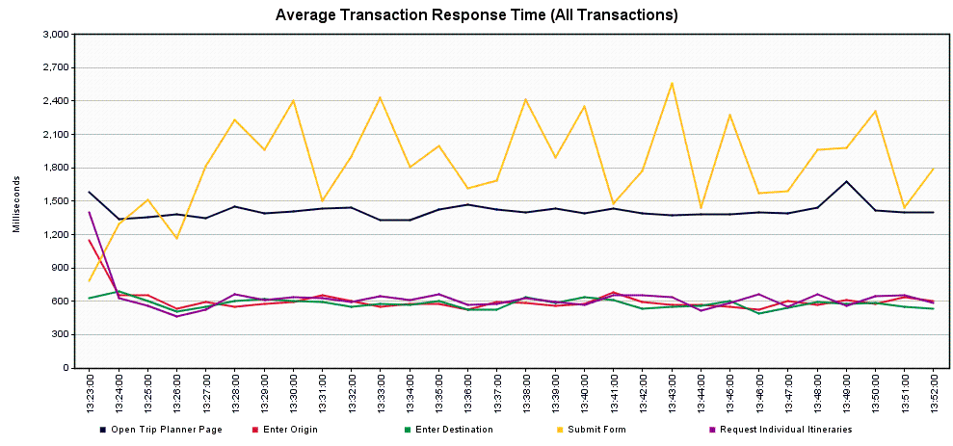

**Scenario 2 – Trip Planner Incremental Increase to Failure**

Scope: This was completed as a series of runs to determine where the service encounters errors or excessively high response times for a significant number of users. In order to push the service, higher load levels were used, beginning with 200 concurrent users and culminating with 400 concurrent users.

*Scenario 2.1 – Trip Planner Incremental Increase to Failure – 200 concurrent users*

Tool: JMeter

JMeter Setup: 200 users, 5-minute ramp-up, Loop “Forever”, Scheduler Enabled, Scheduler Duration 1800 seconds (0.5 hours)

Server: tripplanning-beta.translink.ca

Start Time: 2019-Sep-20 09:58 AM (PDT)

End Time: 2019-Sep-20 10:18 AM (PDT)

Notes: Despite having more than twice as many concurrent users as the historical peak, the response times were much the same as the previous scenario. The Submit transaction remains a possible point of concern, with 10% of users seeing response times of 5 second or more, and 1% of users seeing times of 16 second or more

Running Users

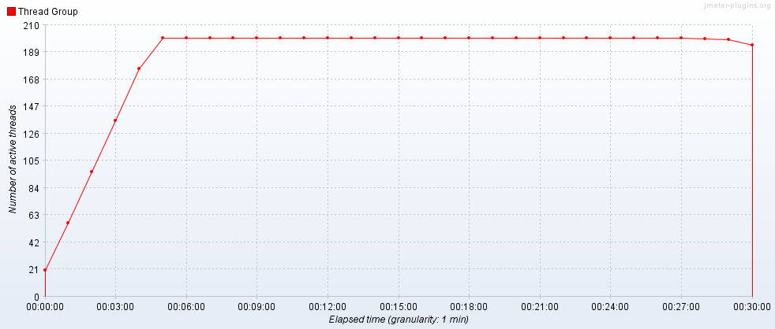

Hits per Second

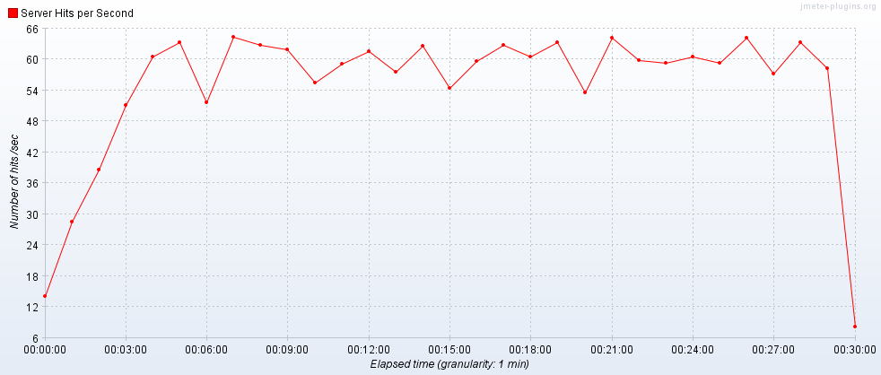

Transactions per Second

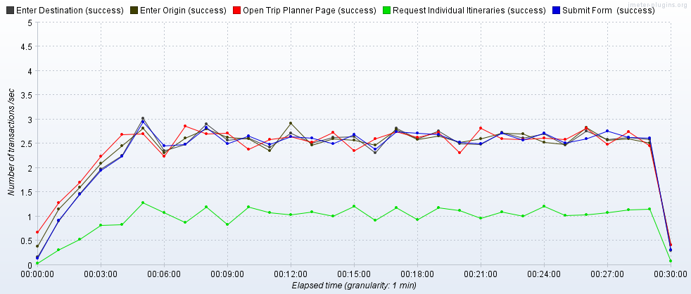

Transaction Statistics

|  |  |  |  |  |  |  |  |  |  |  |  |  |
| --- | --- | --- | --- | --- | --- | --- | --- | --- | --- | --- | --- | --- |
| Label | # Samples | Average | Median | 90% Line | 95% Line | 99% Line | Min | Max | Error % | Throughput | Received KB/sec | Sent KB/sec |
| Open Trip Planner Page | 4450 | 1609 | 1545 | 2041 | 2233 | 2716 | 850 | 6390 | 0.00% | 2.46799 | 10794.99 | 82.76 |
| Enter Origin | 4402 | 520 | 533 | 765 | 922 | 1382 | 88 | 3907 | 0.00% | 2.47055 | 11.16 | 1.13 |
| Enter Destination | 4351 | 520 | 535 | 760 | 893 | 1269 | 88 | 1970 | 0.00% | 2.46477 | 11.22 | 1.13 |
| Submit | 4351 | 2310 | 305 | 5623 | 6791 | 16220 | 103 | 36393 | 0.00% | 2.46259 | 295.06 | 18.69 |
| Request Individual Itineraries | 1774 | 659 | 621 | 949 | 1055 | 1425 | 68 | 4251 | 0.00% | 1.00816 | 163.57 | 13.18 |
| TOTAL | 121375 | 358 | 10 | 930 | 1514 | 4745 | 1 | 36393 | 0.00% | 67.31507 | 22212.26 | 206.58 |

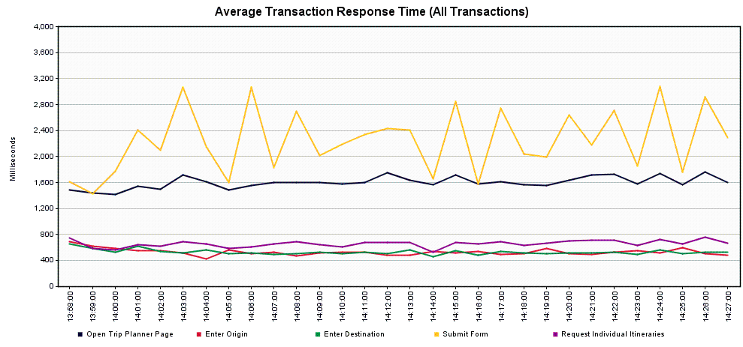

*Scenario 2.2 – Trip Planner Incremental Increase to Failure – 250 concurrent users*

Tool: JMeter

JMeter Setup: 250 users, 5-minute ramp-up, Loop “Forever”, Scheduler Enabled, Scheduler Duration 1800 seconds (0.5 hours)

Server: tripplanning-beta.translink.ca

Start Time: 2019-Sep-20 11:13 AM (PDT)

End Time: 2019-Sep-20 11:43 AM (PDT)

Notes: The service continues to perform at the same level, with no real change from the previous run.

Running Users

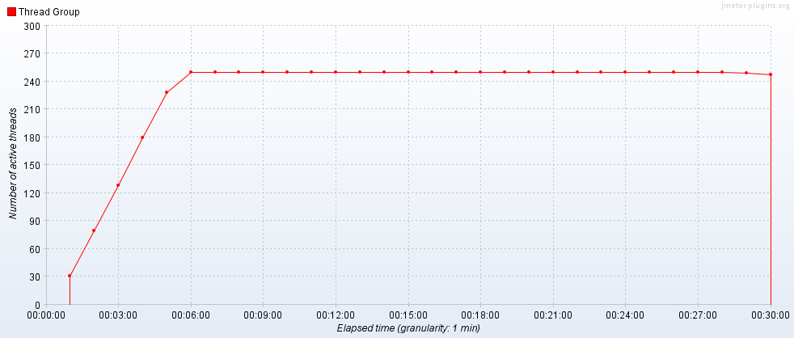

Hits per Second

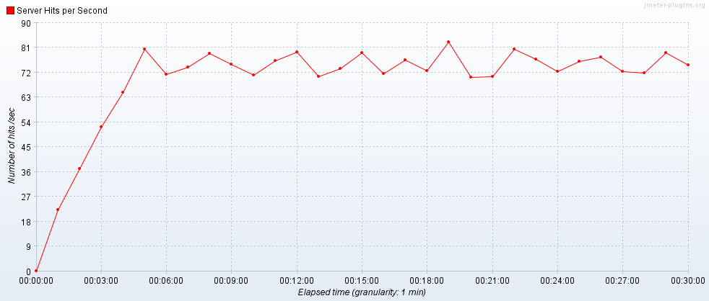

Transactions per Second

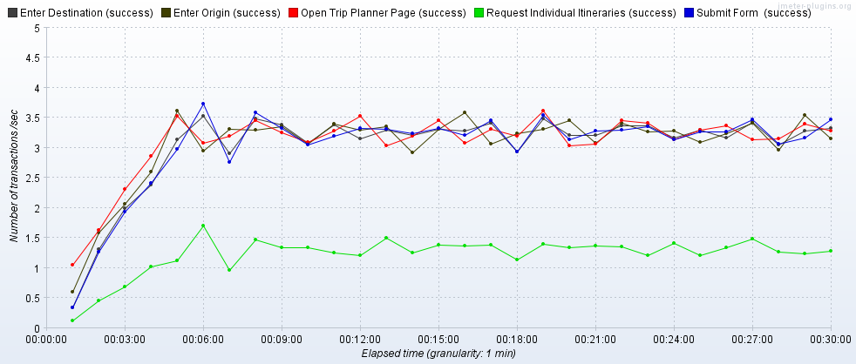

Transaction Statistics

|  |  |  |  |  |  |  |  |  |  |  |  |  |
| --- | --- | --- | --- | --- | --- | --- | --- | --- | --- | --- | --- | --- |
| Label | # Samples | Average | Median | 90% Line | 95% Line | 99% Line | Min | Max | Error % | Throughput | Received KB/sec | Sent KB/sec |
| Open Trip Planner Page | 5576 | 1653 | 1586 | 2133 | 2325 | 2846 | 870 | 4932 | 0.00% | 3.09495 | 13537.29 | 103.79 |
| Enter Origin | 5511 | 531 | 564 | 784 | 885 | 1309 | 87 | 10080 | 0.00% | 3.09537 | 14.04 | 1.42 |
| Enter Destination | 5456 | 527 | 562 | 772 | 865 | 1211 | 90 | 9159 | 0.00% | 3.09521 | 14.05 | 1.42 |
| Submit | 5452 | 2306 | 314 | 5749 | 7027 | 13503 | 103 | 36364 | 0.00% | 3.09202 | 360.76 | 23.15 |
| Request Individual Itineraries | 2194 | 668 | 639 | 971 | 1119 | 1408 | 63 | 3370 | 0.00% | 1.24823 | 197.96 | 16.22 |
| TOTAL | 152050 | 363 | 14 | 918 | 1556 | 4929 | 1 | 36364 | 0.00% | 84.38549 | 27832.79 | 258.43 |

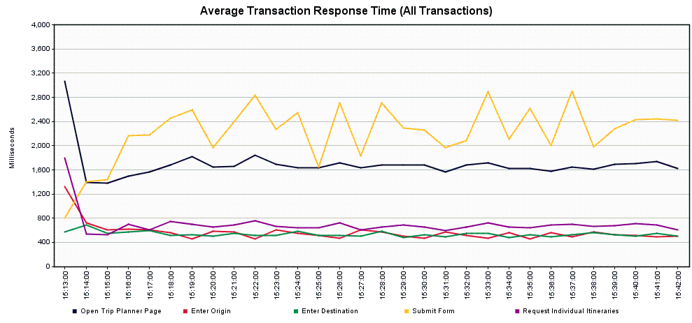

*Scenario 2.3 – Trip Planner Incremental Increase to Failure – 300 concurrent users*

Tool: JMeter

JMeter Setup: 300 users, 5-minute ramp-up, Loop “Forever”, Scheduler Enabled, Scheduler Duration 1800 seconds (0.5 hours)

Server: tripplanning-beta.translink.ca

Start Time: 2019-Sep-20 11:49 AM (PDT)

End Time: 2019-Sep-20 12:09 AM (PDT)

Notes: The transaction times are similar to the previous runs, with slight increases seen. The Submit transaction would likely have 10% of users seeing response times of 6 seconds or more, and 1% of users seeing 14 seconds or more.

Running Users

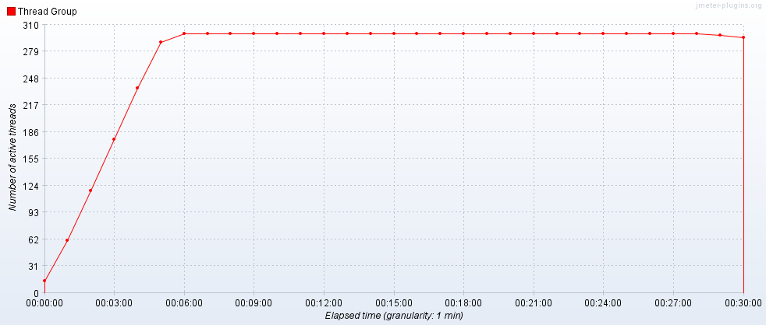

Hits per Second

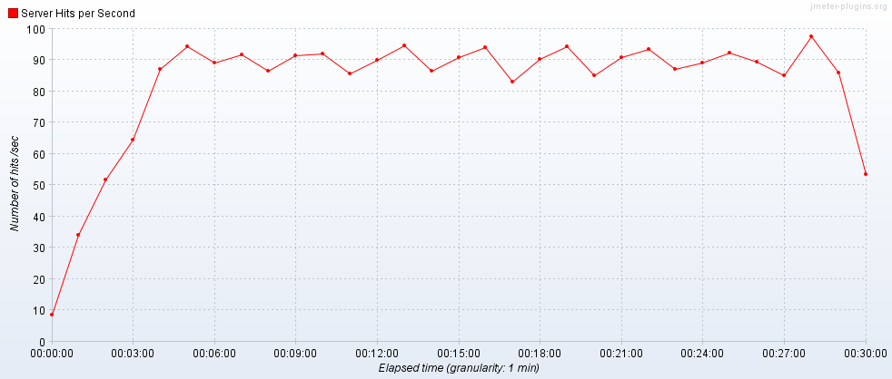

Transactions per Second

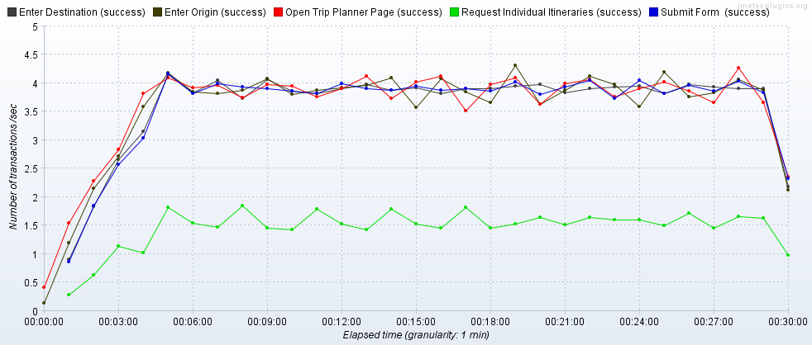

Transaction Statistics

|  |  |  |  |  |  |  |  |  |  |  |  |  |
| --- | --- | --- | --- | --- | --- | --- | --- | --- | --- | --- | --- | --- |
| Label | # Samples | Average | Median | 90% Line | 95% Line | 99% Line | Min | Max | Error % | Throughput | Received KB/sec | Sent KB/sec |
| Open Trip Planner Page | 6661 | 1726 | 1659 | 2250 | 2478 | 2946 | 841 | 4923 | 0.00% | 3.69972 | 16183.17 | 124.08 |
| Enter Origin | 6589 | 474 | 535 | 748 | 851 | 1085 | 89 | 3208 | 0.00% | 3.69803 | 16.72 | 1.69 |
| Enter Destination | 6518 | 477 | 532 | 731 | 818 | 1068 | 86 | 3633 | 0.00% | 3.69862 | 16.82 | 1.69 |
| Submit | 6518 | 2505 | 353 | 6366 | 7883 | 14736 | 108 | 36782 | 0.00% | 3.69423 | 435.63 | 27.85 |
| Request Individual Itineraries | 2635 | 697 | 664 | 1005 | 1146 | 1424 | 64 | 3229 | 0.00% | 1.50009 | 239.06 | 19.6 |
| TOTAL | 181745 | 374 | 15 | 921 | 1607 | 5353 | 1 | 36782 | 0.00% | 100.8229 | 33245.38 | 309.02 |

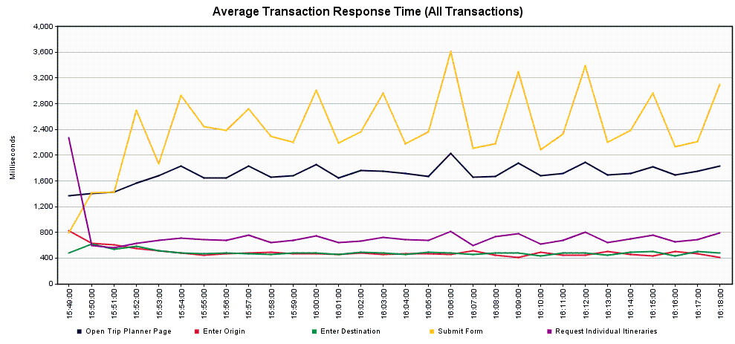

*Scenario 2.4 – Trip Planner Incremental Increase to Failure – 400 concurrent users*

Tool: JMeter

JMeter Setup: 400 users, 5-minute ramp-up, Loop “Forever”, Scheduler Enabled, Scheduler Duration 1800 seconds (0.5 hours)

Server: tripplanning-beta.translink.ca

Start Time: 2019-Sep-20 10:32 AM (PDT)

End Time: 2019-Sep-20 11:02 AM (PDT)

Notes: We seem to have exhausted the number of allowed sockets on this run – we encountered a high number of errors, which meant that no further runs were conducted. The main Trip Planner page started to bog down here, with 10% users likely seeing response times of 3 seconds or more, and 1% of users seeing times of 7 seconds or more. Likewise, the Submit transaction slowed further, with 10% of users seeing response times of 6 seconds or more and 1% of users seeing times of 21 seconds or more. That said, we had the equivalent of ~20,000 users/hour attempting to access the service, which is 5 times higher than the historical peak.

Running Users

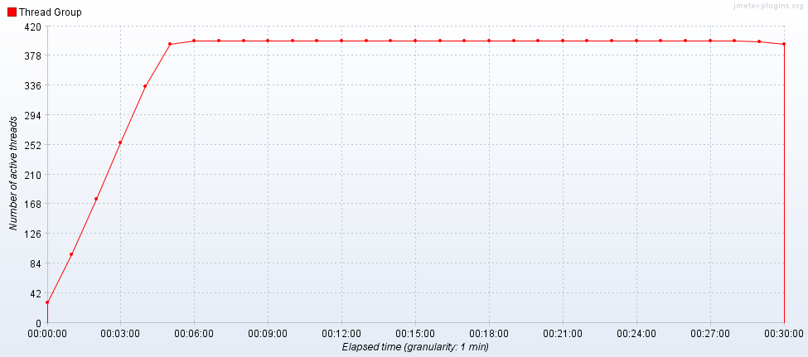

Hits per Second

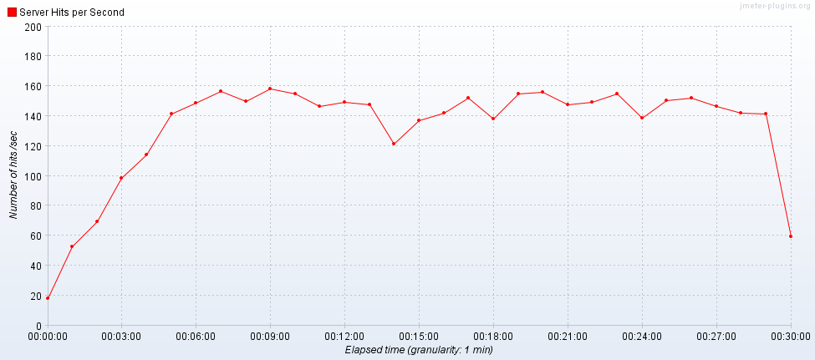

Transactions per Second

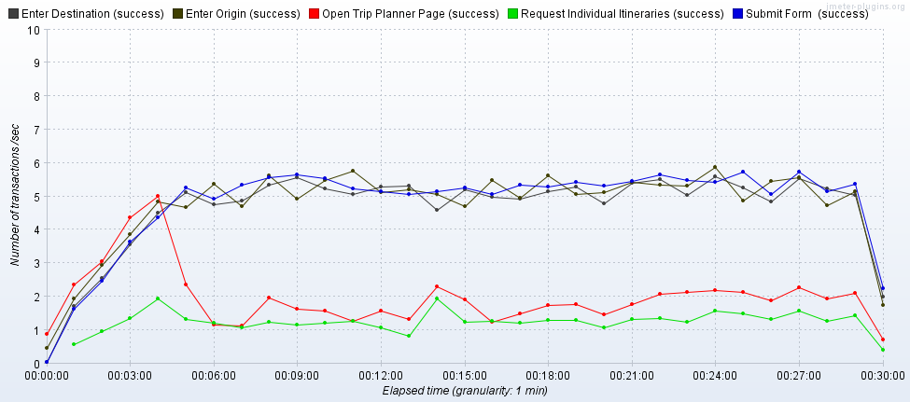

Transaction Statistics

|  |  |  |  |  |  |  |  |  |  |  |  |  |
| --- | --- | --- | --- | --- | --- | --- | --- | --- | --- | --- | --- | --- |
| Label | # Samples | Average | Median | 90% Line | 95% Line | 99% Line | Min | Max | Error % | Throughput | Received KB/sec | Sent KB/sec |
| Open Trip Planner Page | 10707 | 2104 | 1841 | 3018 | 4320 | 7738 | 35 | 39440 | 65.88% | 5.94269 | 18999.97 | 155.94 |
| Enter Origin | 10569 | 370 | 445 | 715 | 803 | 1063 | 1 | 3115 | 16.83% | 5.92951 | 24.96 | 2.26 |
| Enter Destination | 10461 | 360 | 421 | 698 | 782 | 983 | 1 | 3618 | 17.71% | 5.92337 | 24.63 | 2.23 |
| Submit | 10457 | 2135 | 268 | 6578 | 8749 | 21644 | 1 | 48587 | 14.96% | 5.91553 | 435.79 | 30.08 |
| Request Individual Itineraries | 2724 | 754 | 734 | 1172 | 1365 | 1900 | 10 | 3992 | 17.07% | 1.55011 | 227.52 | 18.39 |
| TOTAL | 290449 | 361 | 6 | 802 | 1547 | 5685 | 1 | 48587 | 11.19% | 161.0689 | 38919.24 | 379.42 |

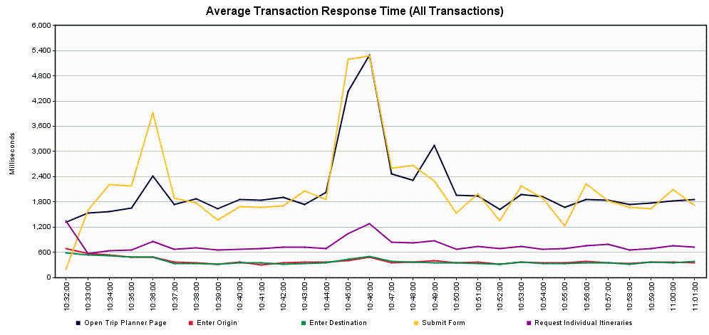

**Scenario 3 – Trip Planner Spike Test**

Scope: This run was completed to determine what happens with a sudden, sustained spike in demand (like a snow day).

Tool: JMeter

JMeter Setup: 180 users, 5-minute ramp-up, Loop “Forever”, Scheduler Enabled, Scheduler Duration 14400 seconds (4 hours)

Server: tripplanning-beta.translink.ca

Start Time: 2019-Sep-19 12:47 PM (PDT)

End Time: 2019-Sep-19 16:47 PM (PDT)

Notes: In this run, we had 3 transactions get “stuck” and not time out properly, so the results are somewhat skewed (as can be seen in the Running Users graph below). If we treat those results as outliers that can be removed, then the results fall into line with our historical peak run. The Submit transaction might be a point of concern, with 5% of users seeing response times of 6 seconds or more, and 1% of users seeing times of 14 seconds or more.

Running Users

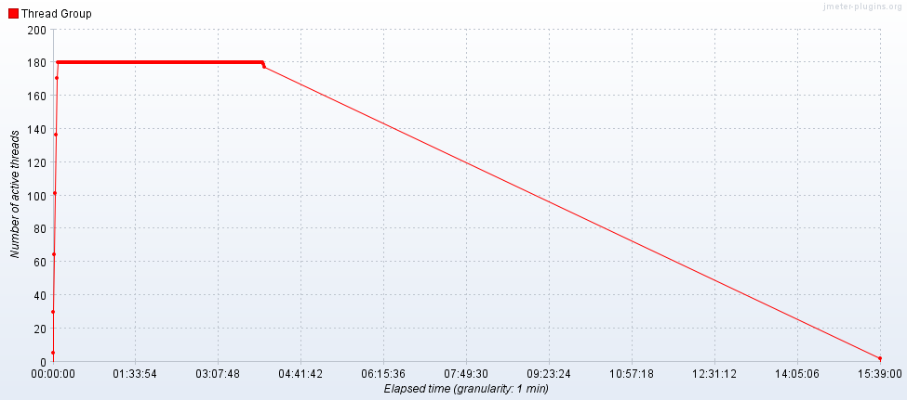

Hits per Second

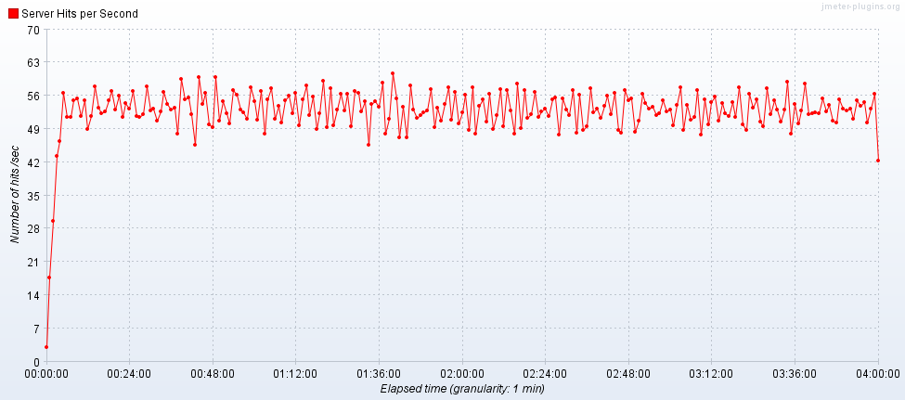

Transactions per Second

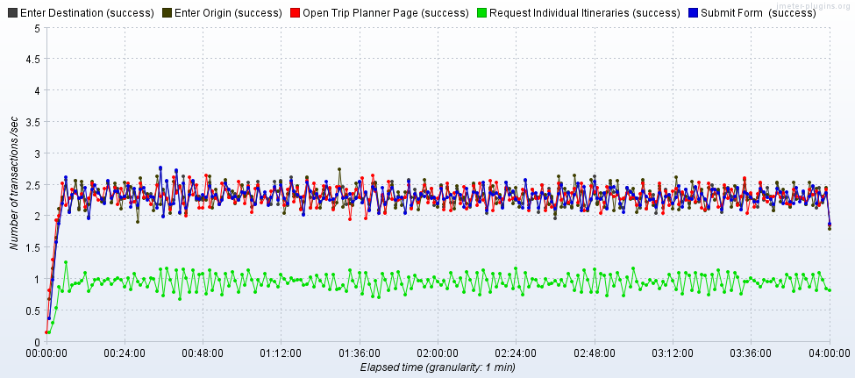

Transaction Statistics

|  |  |  |  |  |  |  |  |  |  |  |  |  |
| --- | --- | --- | --- | --- | --- | --- | --- | --- | --- | --- | --- | --- |
| Label | # Samples | Average | Median | 90% Line | 95% Line | 99% Line | Min | Max | Error % | Throughput | Received KB/sec | Sent KB/sec |
| Open Trip Planner Page | 33173 | 1593 | 1531 | 2017 | 2196 | 2624 | 805 | 15244 | 0.02% | 2.30357 | 10071.54 | 77.24 |
| Enter Origin | 33128 | 2047 | 549 | 756 | 846 | 1080 | 85 | 50433308 | 0.04% | 0.58856 | 2.68 | 0.27 |
| Enter Destination | 33083 | 2065 | 550 | 749 | 831 | 1051 | 87 | 51033962 | 0.02% | 0.58795 | 2.67 | 0.27 |
| Submit | 33082 | 2365 | 298 | 5469 | 6708 | 14221 | 1 | 1799978 | 0.02% | 2.30234 | 274.26 | 17.51 |
| Request Individual Itineraries | 13573 | 660 | 624 | 964 | 1108 | 1392 | 58 | 3687 | 0.00% | 0.94556 | 150.18 | 12.33 |
| TOTAL | 908754 | 588 | 11 | 914 | 1510 | 4656 | 1 | 51033962 | 0.02% | 16.13969 | 5302.45 | 49.52 |

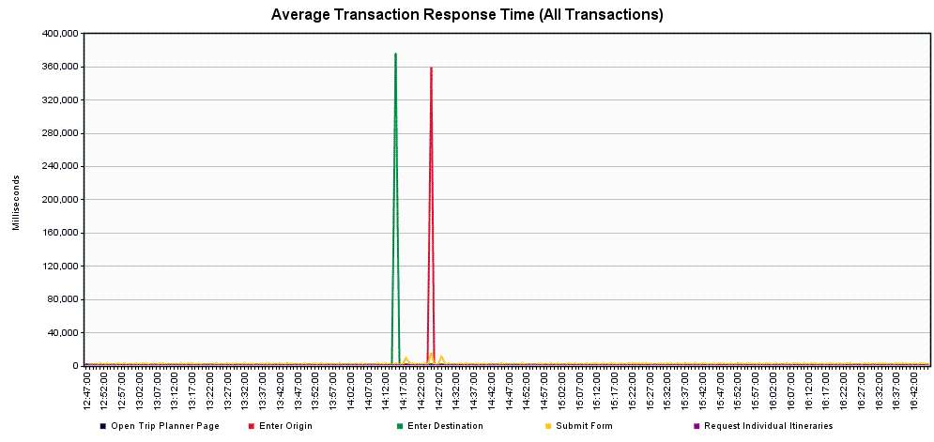

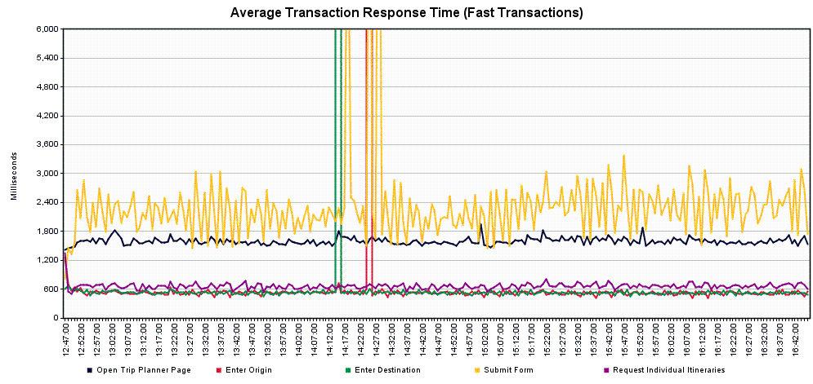

**Scenario 4 – Trip Planner Future Capacity**

Scope: This was completed as a series of runs to examine how the service would cope with an expected 10% yearly increase, for 5 years. The current, typical, daily usage of approximately 1400 users/hour was applied to the system.

*Scenario 4.1 – Trip Planner Future Capacity – Year 0 (baseline/current)*

Tool: JMeter

JMeter Setup: 32 users, 5-minute ramp-up, Loop “Forever”, Scheduler Enabled, Scheduler Duration 1800 seconds (0.5 Hours)

Server: tripplanning-beta.translink.ca

Start Time: 2019-Sep-19 12:11 PM (PDT)

End Time: 2019-Sep-19 12:41 PM (PDT)

Notes: This run should correspond with the existing traffic in production. The Submit transaction might be a point of concern, 5% of users would likely see response times of just under 5 seconds or more, 1% of users would see times of 8 seconds or more.

Running Users

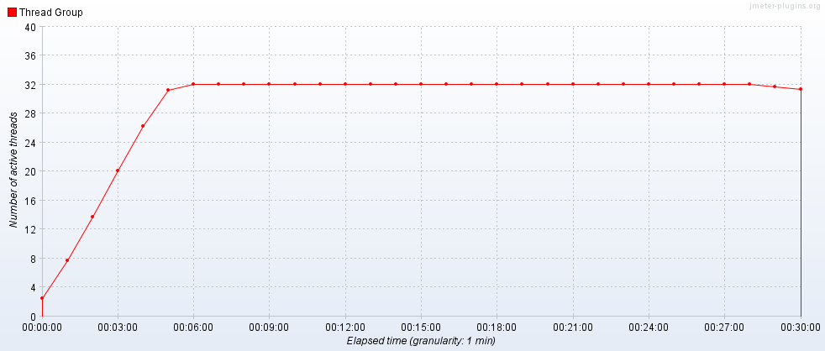

Hits per Second

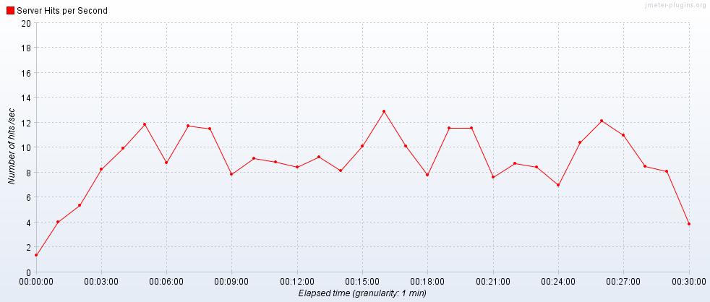

Transactions per Second

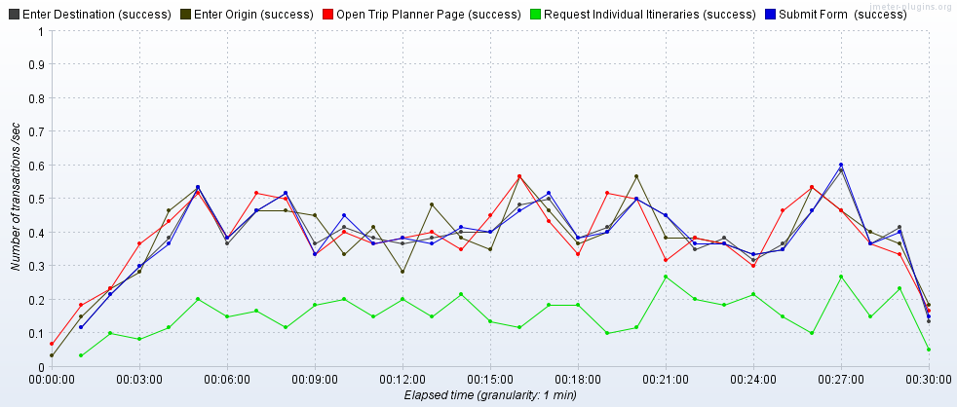

Transaction Statistics

|  |  |  |  |  |  |  |  |  |  |  |  |  |
| --- | --- | --- | --- | --- | --- | --- | --- | --- | --- | --- | --- | --- |
| Label | # Samples | Average | Median | 90% Line | 95% Line | 99% Line | Min | Max | Error % | Throughput | Received KB/sec | Sent KB/sec |
| Open Trip Planner Page | 716 | 1398 | 1347 | 1681 | 1911 | 2529 | 959 | 5032 | 0.00% | 0.39935 | 1746.82 | 13.4 |
| Enter Origin | 711 | 655 | 625 | 860 | 996 | 1336 | 99 | 1913 | 0.00% | 0.3993 | 1.82 | 0.18 |
| Enter Destination | 704 | 651 | 614 | 828 | 937 | 1211 | 91 | 6782 | 0.00% | 0.39933 | 1.82 | 0.18 |
| Submit | 704 | 1754 | 222 | 4233 | 4861 | 8169 | 153 | 33238 | 0.00% | 0.39902 | 46.82 | 2.99 |
| Request Individual Itineraries | 283 | 589 | 542 | 873 | 1063 | 1254 | 75 | 1536 | 0.00% | 0.1628 | 25.86 | 2.12 |
| TOTAL | 19557 | 323 | 5 | 899 | 1341 | 3740 | 1 | 33238 | 0.00% | 10.85902 | 3576.91 | 33.25 |

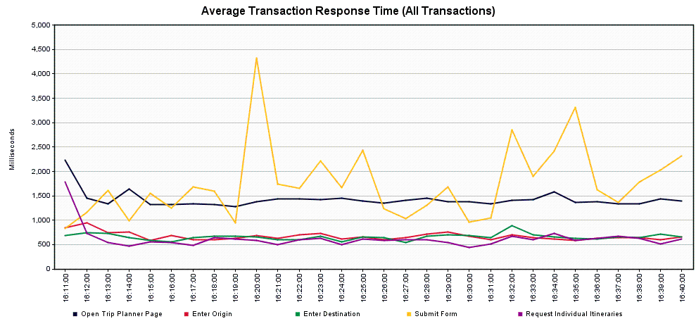

*Scenario 4.2 – Trip Planner Future Capacity – Year 1 (1540 users/10% increase over previous year)*

Tool: JMeter

JMeter Setup: 34 users, 5-minute ramp-up, Loop “Forever”, Scheduler Enabled, Scheduler Duration 1800 seconds (0.5 Hours)

Server: tripplanning-beta.translink.ca

Start Time: 2019-Sep-20 06:03 AM (PDT)

End Time: 2019-Sep-20 06:33 AM (PDT)

Notes: The results of this run are much the same as the previous one, with a slight increase in the response times of the Submit transaction for 1% of users – they would likely see times of 10 seconds or more.

Running Users

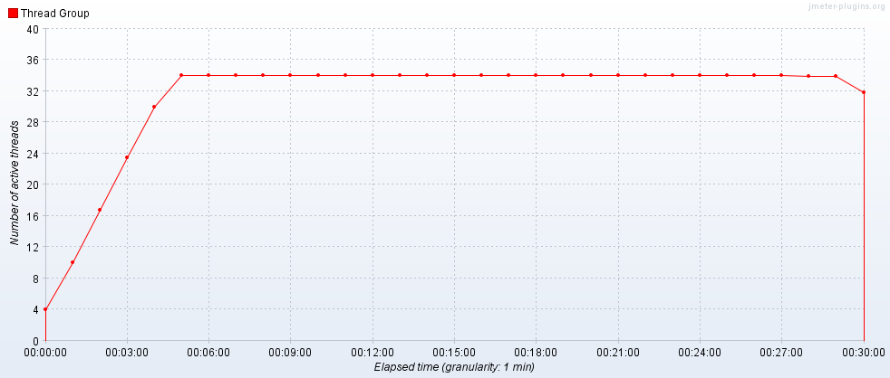

Hits per Second

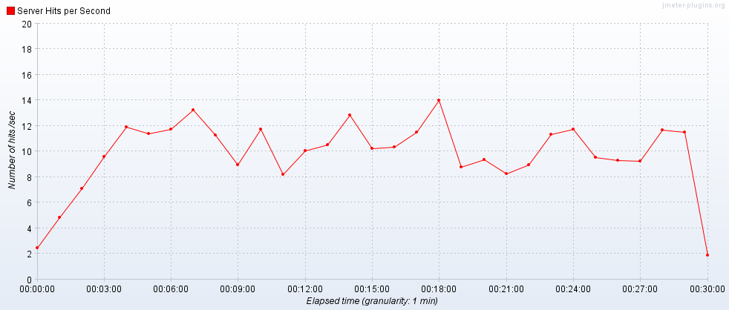

Transactions per Second

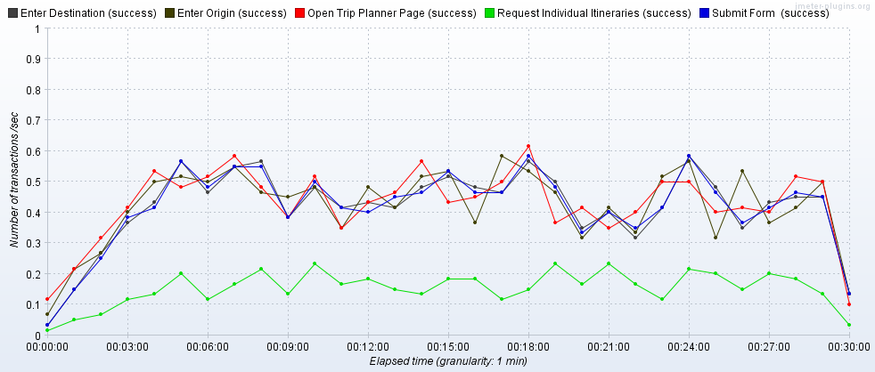

Transaction Statistics

|  |  |  |  |  |  |  |  |  |  |  |  |  |
| --- | --- | --- | --- | --- | --- | --- | --- | --- | --- | --- | --- | --- |
| Label | # Samples | Average | Median | 90% Line | 95% Line | 99% Line | Min | Max | Error % | Throughput | Received KB/sec | Sent KB/sec |
| Open Trip Planner Page | 795 | 1338 | 1300 | 1610 | 1726 | 2079 | 784 | 4982 | 0.00% | 0.44158 | 1931.26 | 14.8 |
| Enter Origin | 785 | 608 | 588 | 785 | 889 | 1155 | 93 | 1939 | 0.00% | 0.44094 | 1.94 | 0.2 |
| Enter Destination | 775 | 597 | 577 | 764 | 860 | 1088 | 92 | 1561 | 0.00% | 0.43952 | 1.98 | 0.2 |
| Submit | 775 | 1890 | 317 | 4425 | 5029 | 10243 | 121 | 30196 | 0.00% | 0.43935 | 44.3 | 3.05 |
| Request Individual Itineraries | 285 | 563 | 536 | 830 | 982 | 1160 | 58 | 1434 | 0.00% | 0.16233 | 23.73 | 2.07 |
| TOTAL | 21612 | 321 | 5 | 844 | 1287 | 3788 | 1 | 30196 | 0.00% | 12.00324 | 3956.69 | 36.36 |

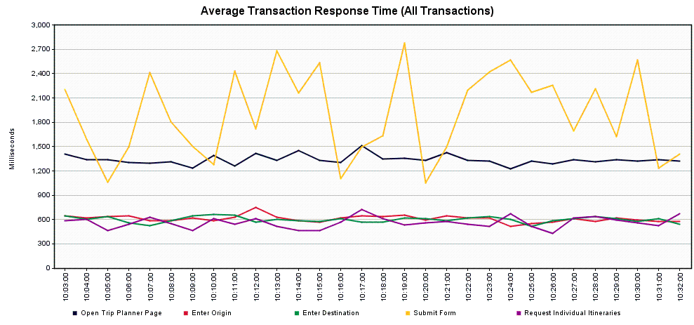

*Scenario 4.3 – Trip Planner Future Capacity – Year 2 (1694 users/10% increase over previous year)*

Tool: JMeter

JMeter Setup: 36 users, 5-minute ramp-up, Loop “Forever”, Scheduler Enabled, Scheduler Duration 1800 seconds (0.5 Hours)

Server: trippplaning-beta.translink.ca

Start Time: 2019-Sep-20 05:29 AM (PDT)

End Time: 2019-Sep-20 05:59 AM (PDT)

Notes: This run had a bit of a jump in the response times for the Submit transaction, but since no errors occurred, we don’t have the actual origins and destinations that had the long response times. 5% of users would likely see response times of 6 seconds or more, 1% of users saw times of 30 seconds or more.

Running Users

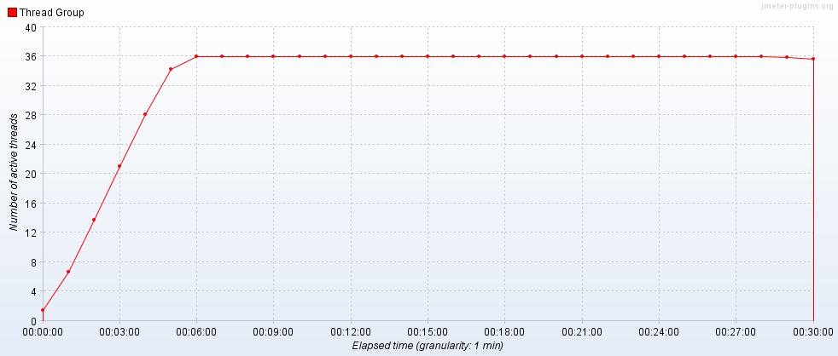

Hits per Second

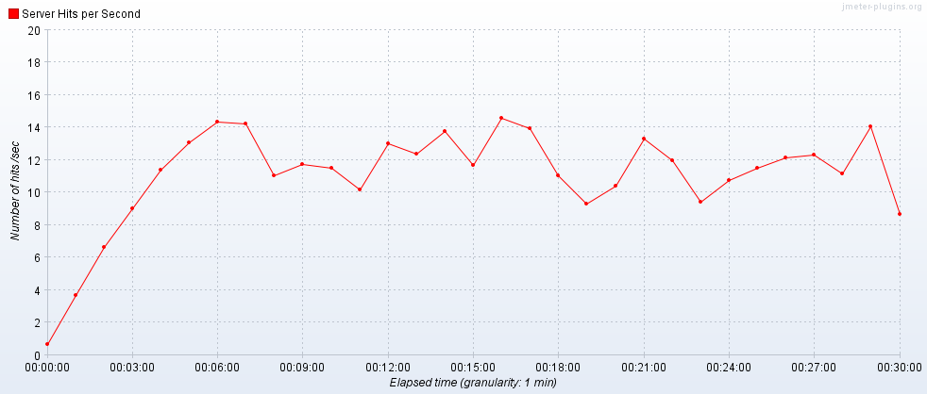

Transactions per Second

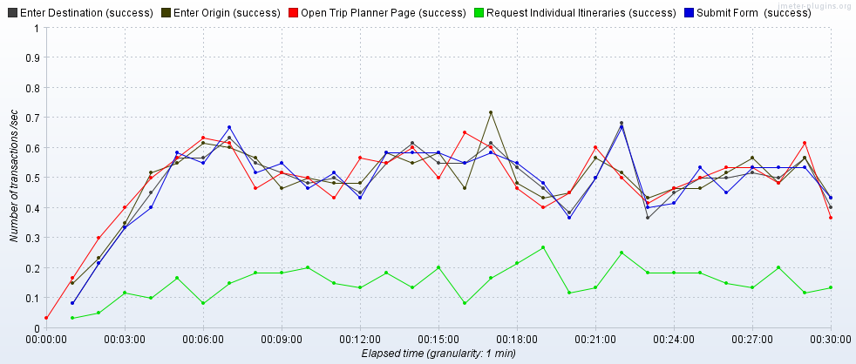

Transaction Statistics

|  |  |  |  |  |  |  |  |  |  |  |  |  |
| --- | --- | --- | --- | --- | --- | --- | --- | --- | --- | --- | --- | --- |
| Label | # Samples | Average | Median | 90% Line | 95% Line | 99% Line | Min | Max | Error % | Throughput | Received KB/sec | Sent KB/sec |
| Open Trip Planner Page | 896 | 1323 | 1275 | 1587 | 1798 | 2192 | 818 | 5294 | 0.00% | 0.49878 | 2181.76 | 16.74 |
| Enter Origin | 888 | 640 | 626 | 824 | 930 | 1162 | 85 | 1662 | 0.00% | 0.5001 | 2.15 | 0.23 |
| Enter Destination | 876 | 637 | 623 | 821 | 900 | 1138 | 94 | 2063 | 0.00% | 0.49844 | 2.26 | 0.23 |
| Submit | 876 | 2265 | 326 | 4634 | 6564 | 30180 | 114 | 35778 | 0.00% | 0.49796 | 41.07 | 3.05 |
| Request Individual Itineraries | 275 | 556 | 531 | 866 | 936 | 1313 | 51 | 1777 | 0.00% | 0.15725 | 21.94 | 1.94 |
| TOTAL | 24371 | 352 | 5 | 846 | 1233 | 3921 | 1 | 35778 | 0.00% | 13.52588 | 4439.23 | 40.22 |

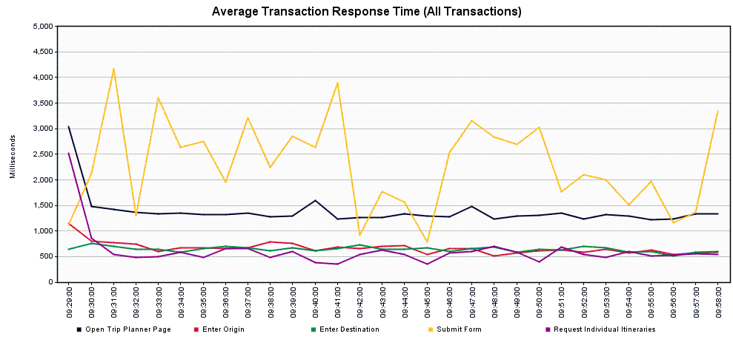

*Scenario 4.4 – Trip Planner Future Capacity – Year 3 (1863 users/10% increase over previous year)*

Tool: JMeter

JMeter Setup: 42 users, 5-minute ramp-up, Loop “Forever”, Scheduler Enabled, Scheduler Duration 1800 seconds (0.5 Hours)

Server: tripplanning-beta.translink.ca

Start Time: 2019-Sep-20 07:45 AM (PDT)

End Time: 2019-Sep-20 08:15 AM (PDT)

Notes: The servers rebooted during this run, causing a spike in transaction times and a number of transactional errors, in the form of socket resets. The Submit transaction continues to occasionally have high response times with 5% of users seeing times of 5 seconds or more and 1% of users seeing 32 seconds or more.

Running Users

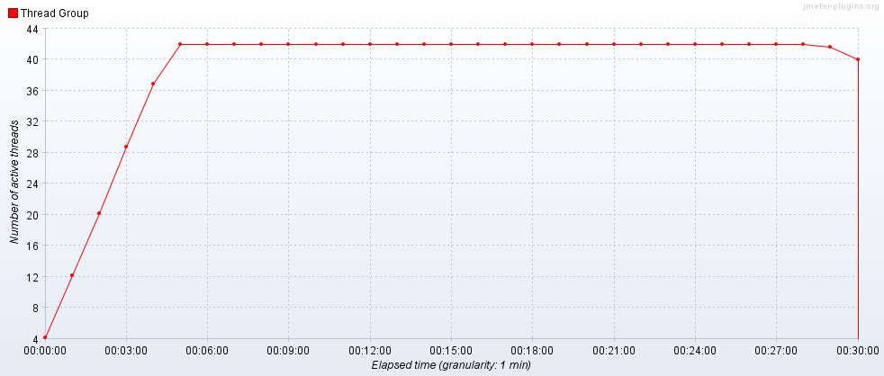

Hits per Second

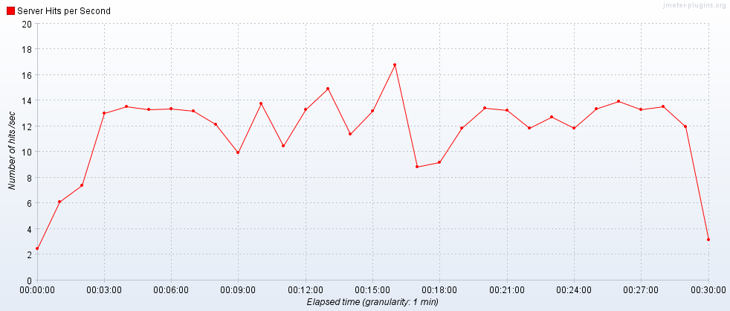

Transactions per Second

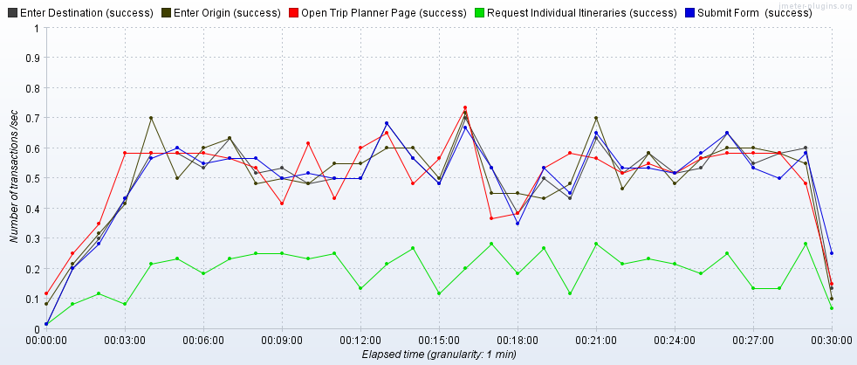

Transaction Statistics

|  |  |  |  |  |  |  |  |  |  |  |  |  |
| --- | --- | --- | --- | --- | --- | --- | --- | --- | --- | --- | --- | --- |
| Label | # Samples | Average | Median | 90% Line | 95% Line | 99% Line | Min | Max | Error % | Throughput | Received KB/sec | Sent KB/sec |
| Open Trip Planner Page | 941 | 1502 | 1379 | 1738 | 1946 | 3548 | 919 | 33229 | 0.43% | 0.52346 | 2274.28 | 17.47 |
| Enter Origin | 932 | 629 | 592 | 812 | 954 | 1484 | 92 | 4007 | 0.22% | 0.5241 | 2.23 | 0.24 |
| Enter Destination | 926 | 630 | 595 | 813 | 953 | 1415 | 95 | 4008 | 0.22% | 0.52664 | 2.33 | 0.24 |
| Submit | 926 | 2965 | 241 | 4586 | 5838 | 32928 | 2 | 121470 | 0.22% | 0.5204 | 58 | 3.77 |
| Request Individual Itineraries | 356 | 593 | 562 | 817 | 949 | 1291 | 77 | 1396 | 0.00% | 0.20239 | 31.86 | 2.63 |
| TOTAL | 25685 | 414 | 6 | 909 | 1408 | 4006 | 1 | 121470 | 0.11% | 14.13734 | 4623.05 | 42.9 |

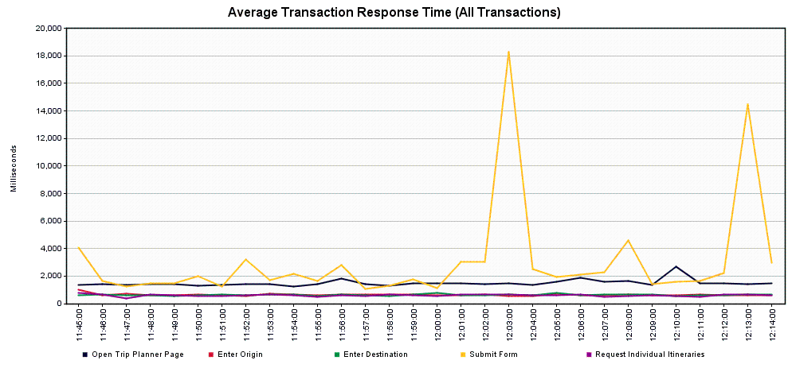

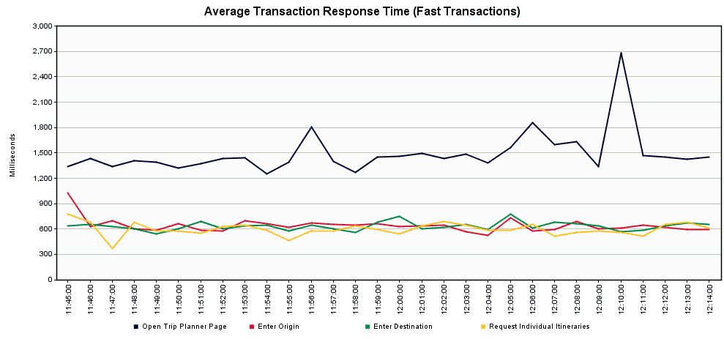

*Scenario 4.5 – Trip Planner Future Capacity – Year 4 (2049 users/10% increase over previous year)*

Tool: JMeter

JMeter Setup: 46 users, 5-minute ramp-up, Loop “Forever”, Scheduler Enabled, Scheduler Duration 1800 seconds (0.5 Hours)

Server: tripplanning-beta.translink.ca

Start Time: 2019-Sep-20 08:20 AM (PDT)

End Time: 2019-Sep-20 08:50 AM (PDT)

Notes: We see some errors occurring in this run (all errors appear to be socket resets or timeouts), suggesting that the server reboot cycle continued through the run. The Submit transaction slowed from the previous run, with 5% of users seeing times of 6 seconds or more, and 1% of users seeing times of 89 seconds or more. That said, the longer response times tend to correspond with the transactional errors.

Running Users

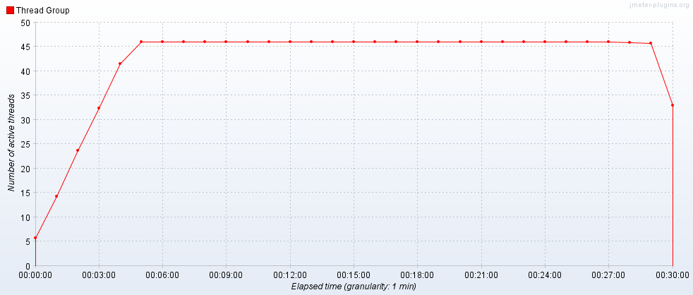

Hits per Second

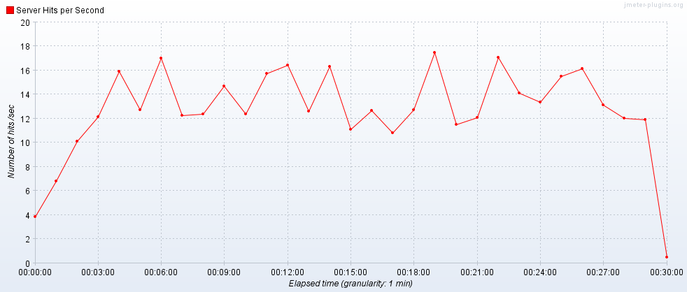

Transactions per Second

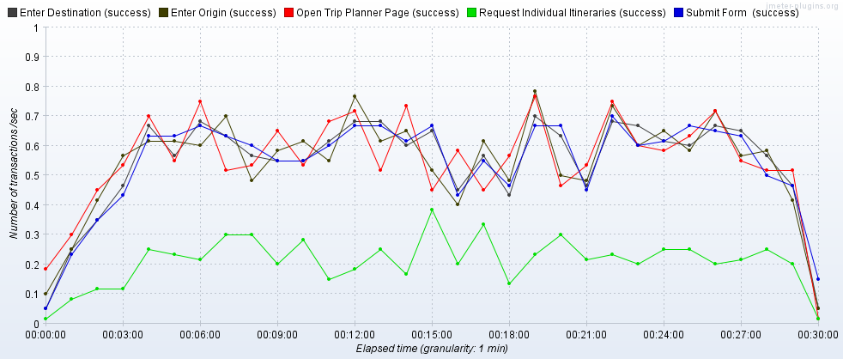

Transaction Statistics

|  |  |  |  |  |  |  |  |  |  |  |  |  |
| --- | --- | --- | --- | --- | --- | --- | --- | --- | --- | --- | --- | --- |
| Label | # Samples | Average | Median | 90% Line | 95% Line | 99% Line | Min | Max | Error % | Throughput | Received KB/sec | Sent KB/sec |
| Open Trip Planner Page | 1027 | 1476 | 1387 | 1713 | 1883 | 2520 | 237 | 33752 | 0.39% | 0.57147 | 2486.44 | 19.07 |
| Enter Origin | 1017 | 651 | 592 | 829 | 1010 | 1790 | 95 | 4010 | 0.79% | 0.57124 | 2.53 | 0.26 |
| Enter Destination | 1010 | 646 | 591 | 878 | 1034 | 1477 | 91 | 4007 | 0.30% | 0.57317 | 2.47 | 0.26 |
| Submit | 1010 | 3581 | 247 | 4642 | 6054 | 89233 | 3 | 300001 | 0.40% | 0.57123 | 64.78 | 4.17 |
| Request Individual Itineraries | 389 | 618 | 577 | 906 | 1041 | 1327 | 78 | 1672 | 0.00% | 0.22137 | 35.4 | 2.91 |
| TOTAL | 28030 | 460 | 7 | 916 | 1420 | 4013 | 1 | 300001 | 0.27% | 15.52571 | 5086.78 | 47.16 |

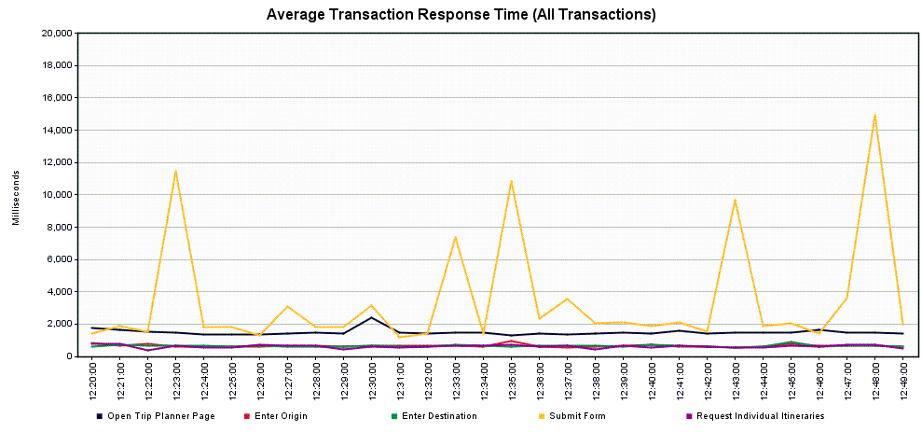

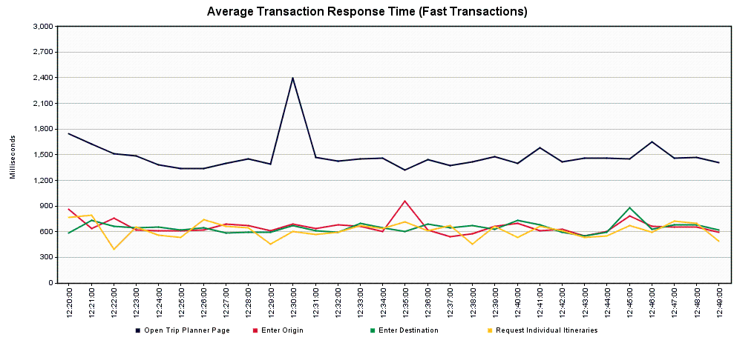

*Scenario 4.6 – Trip Planner Future Capacity – Year 5 (2254 users/10% increase over previous year)*

Tool: JMeter

JMeter Setup: 52 users, 5-minute ramp-up, Loop “Forever”, Scheduler Enabled, Scheduler Duration 1800 seconds (0.5 Hours)

Server: tripplanning-beta.translink.ca

Start Time: 2019-Sep-20 10:49 AM (PDT)

End Time: 2019-Sep-20 11:39 AM (PDT)

Notes: With the server reboot cycle apparently complete, the response times return to a more normal level. The Submit transaction drops down to 5% of users seeing times of 5 second or more and 1% of users seeing times of 15 seconds or more.

Running Users

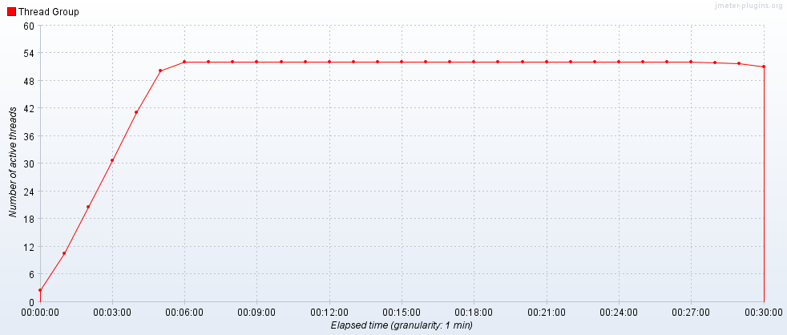

Hits per Second

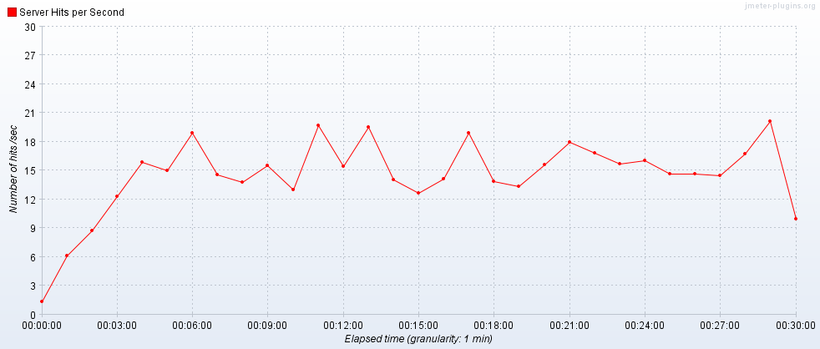

Transactions per Second

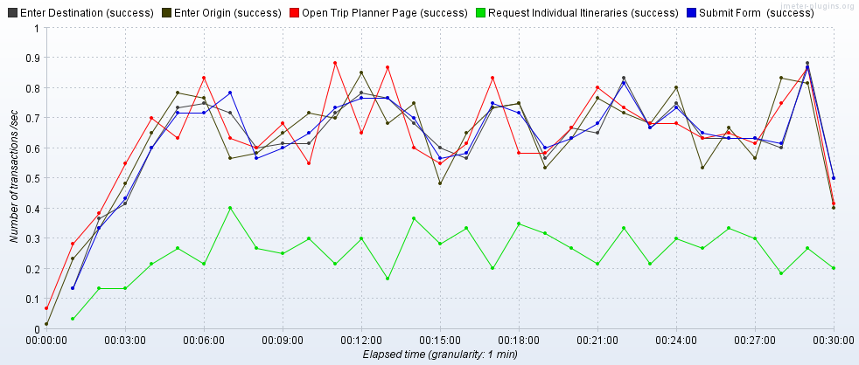

Transaction Statistics

|  |  |  |  |  |  |  |  |  |  |  |  |  |
| --- | --- | --- | --- | --- | --- | --- | --- | --- | --- | --- | --- | --- |
| Label | # Samples | Average | Median | 90% Line | 95% Line | 99% Line | Min | Max | Error % | Throughput | Received KB/sec | Sent KB/sec |
| Open Trip Planner Page | 1175 | 1374 | 1333 | 1666 | 1810 | 2165 | 878 | 4910 | 0.00% | 0.65292 | 2855.98 | 21.9 |
| Enter Origin | 1160 | 610 | 578 | 822 | 969 | 1305 | 97 | 1976 | 0.00% | 0.65086 | 2.88 | 0.3 |
| Enter Destination | 1150 | 599 | 572 | 784 | 922 | 1273 | 91 | 2271 | 0.00% | 0.65126 | 2.91 | 0.3 |
| Submit | 1149 | 1916 | 231 | 4314 | 5323 | 15949 | 102 | 34439 | 0.00% | 0.65182 | 75.83 | 4.87 |
| Request Individual Itineraries | 458 | 578 | 543 | 854 | 930 | 1187 | 68 | 2540 | 0.00% | 0.26121 | 41.85 | 3.42 |
| TOTAL | 32051 | 325 | 5 | 875 | 1320 | 3757 | 1 | 34439 | 0.00% | 17.80306 | 5869.68 | 54.49 |

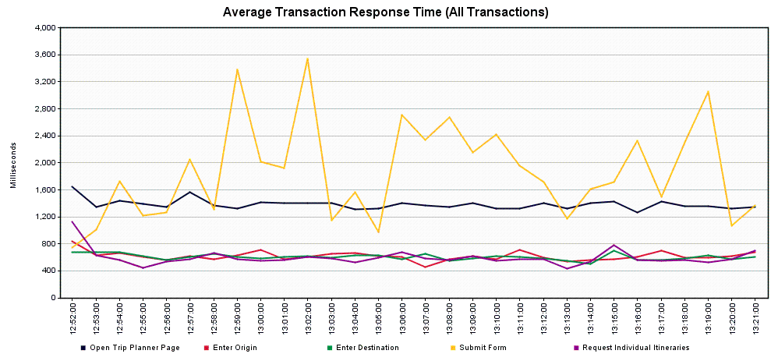

**Scenario 5 – Trip Planner Endurance Test**

Scope: This run was completed to determine whether a very long run at peak loads causes any issues to the service. A load level of 5000 users/hour was the target.

Tool: JMeter

JMeter Setup: 100 users, 5-minute ramp-up, Loop “Forever”, Scheduler Enabled, Scheduler Duration 86400 seconds (24 Hours)

Server: tripplanning-beta.translink.ca

Start Time: 2019-Sep-20 12:28 PM (PDT)

End Time: 2019-Sep-21 12:28 PM (PDT)

Notes: Overall, the service performed well. We had few errors, all of which were socket resets or timeouts, and the errors were generally clustered around the server reboot cycles. These errors tended to correspond to the higher response times that we see. There is a brief spike in the server hits/second and transactions/second around midnight, which makes me think that some network resources were freed up around that time.

The Submit transaction may be a point of concern, with 5% of users likely seeing response times of 5 seconds or more, and 1% of users seeing times of 20 seconds or more.

Running Users

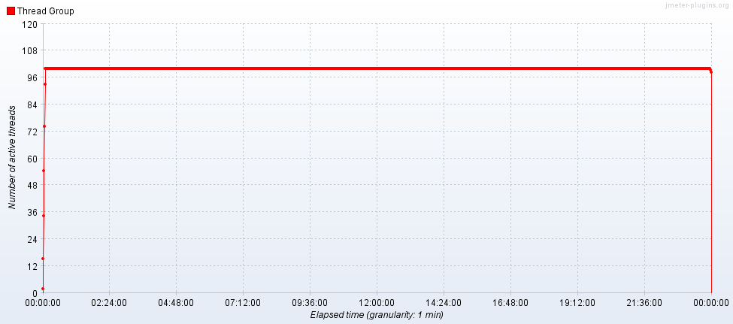

Hits per Second

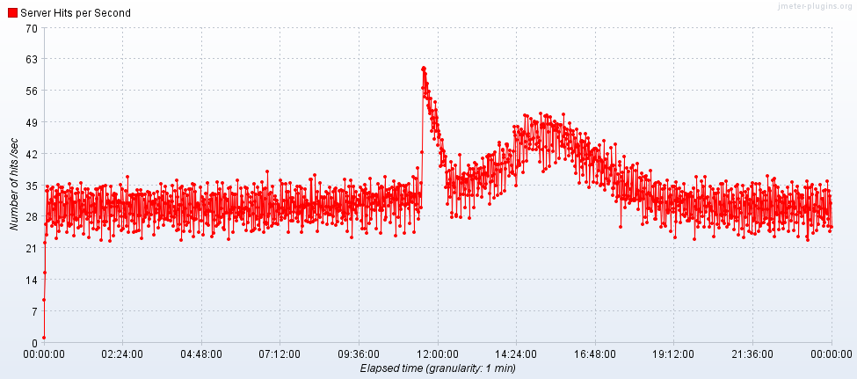

Transactions per Second

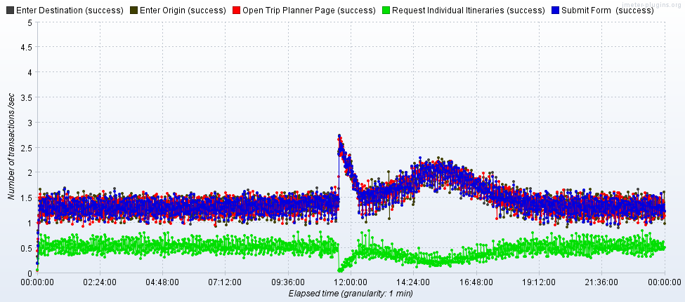

Transaction Statistics

|  |  |  |  |  |  |  |  |  |  |  |  |  |
| --- | --- | --- | --- | --- | --- | --- | --- | --- | --- | --- | --- | --- |
| Label | # Samples | Average | Median | 90% Line | 95% Line | 99% Line | Min | Max | Error % | Throughput | Received KB/sec | Sent KB/sec |
| Open Trip Planner Page | 125093 | 1438 | 1370 | 1771 | 1937 | 2405 | 167 | 302524 | 0.12% | 1.44782 | 6326.27 | 48.52 |
| Enter Origin | 125072 | 546 | 542 | 735 | 826 | 1075 | 5 | 300006 | 0.08% | 1.44792 | 6.58 | 0.66 |
| Enter Destination | 125050 | 536 | 541 | 729 | 816 | 1055 | 10 | 300006 | 0.07% | 1.44797 | 6.58 | 0.66 |
| Submit | 125051 | 1998 | 270 | 4605 | 5725 | 20545 | 1 | 362630 | 0.07% | 1.44793 | 131.76 | 9.27 |
| Request Individual Itineraries | 40868 | 595 | 556 | 861 | 969 | 1260 | 46 | 359124 | 0.01% | 0.47325 | 71.38 | 6 |
| TOTAL | 3418110 | 330 | 6 | 819 | 1297 | 3963 | 1 | 362630 | 0.06% | 39.55938 | 12941.69 | 118.21 |

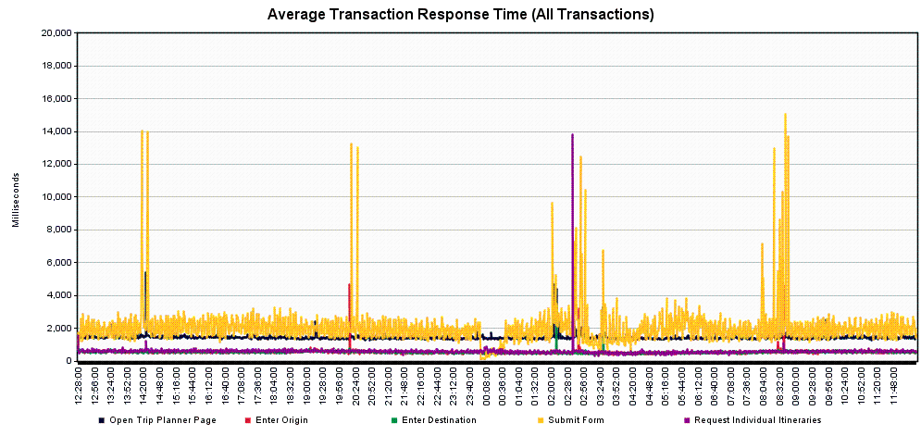

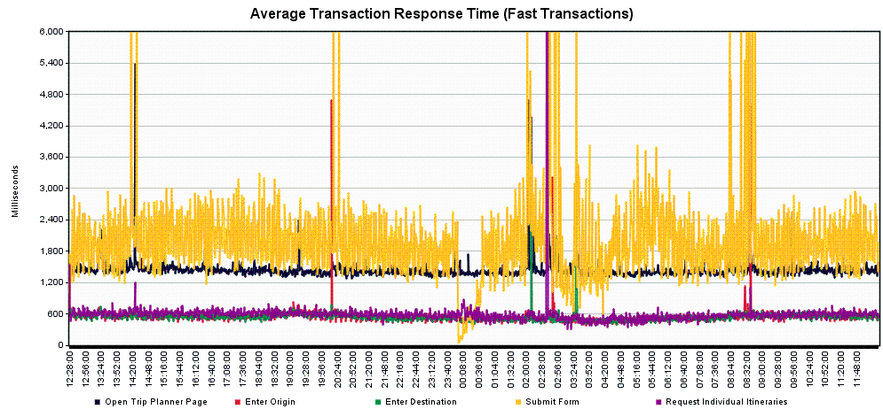

Server Graphs

*TRPPLNWEBP001*

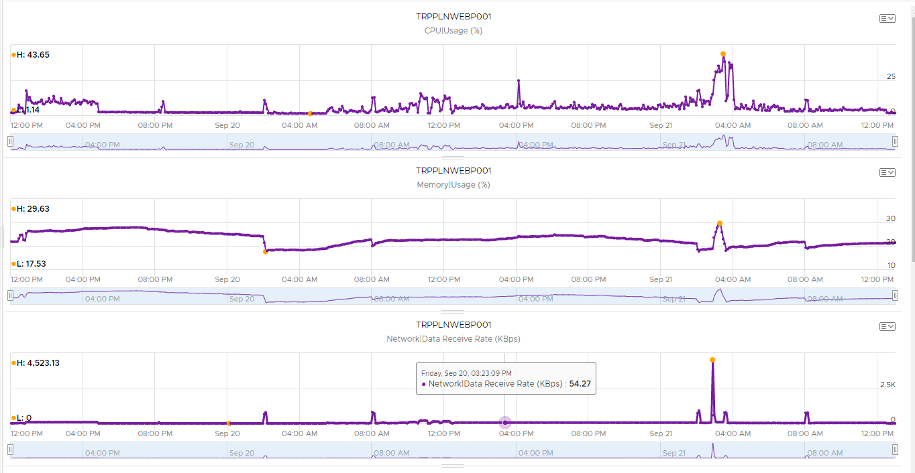

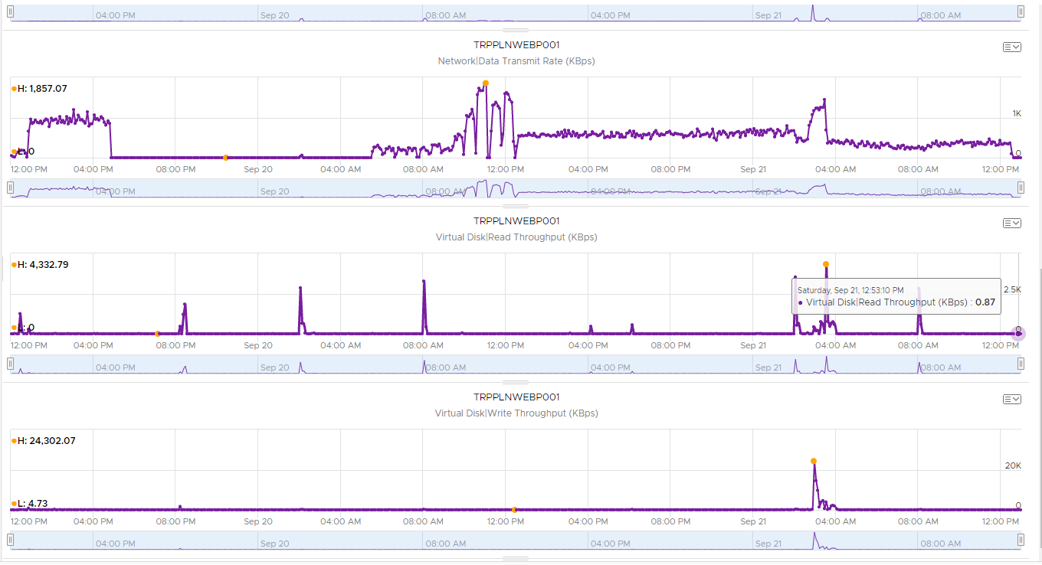

*TRPPLNWEBP002* (002 had brief peaks in memory usage above 50%, but the peaks were short duration)

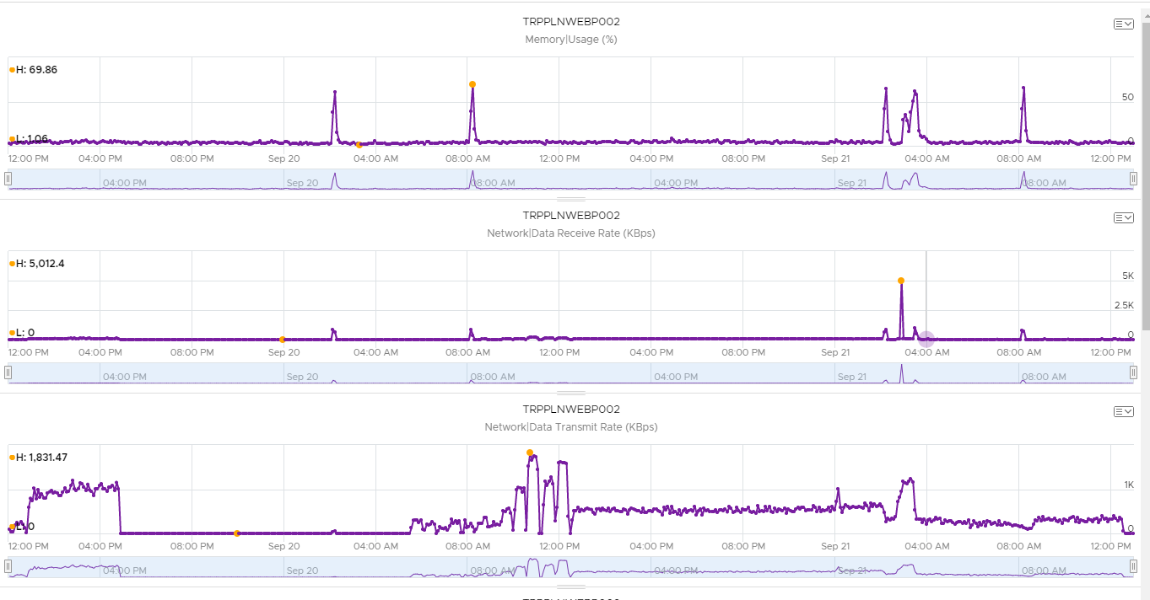

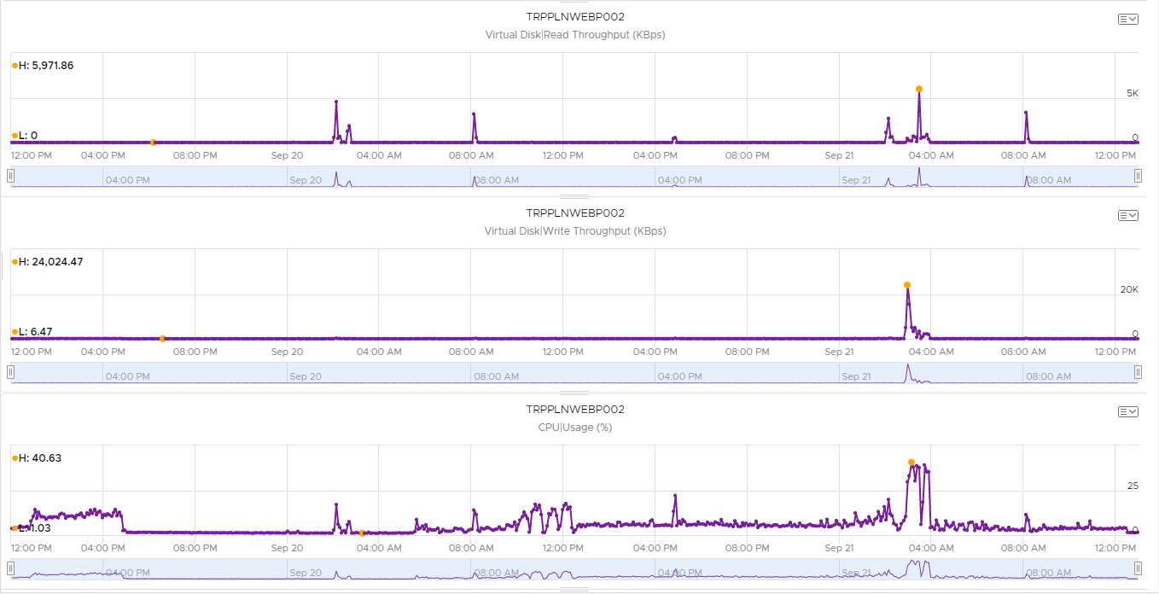

*TRPPLNWEBP003*

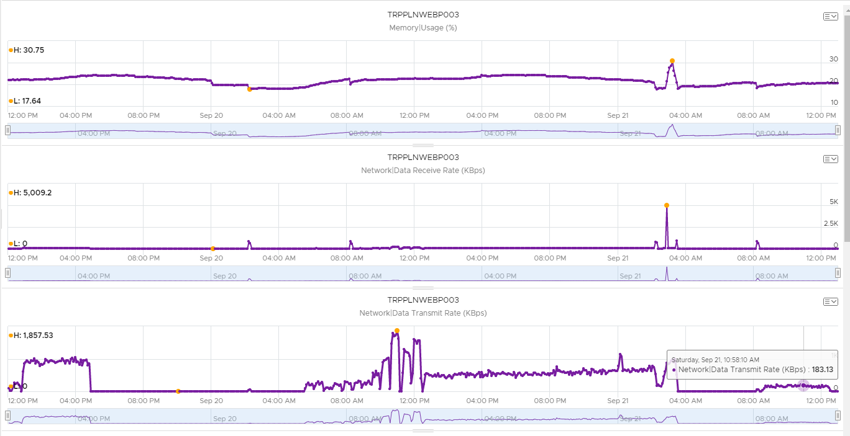

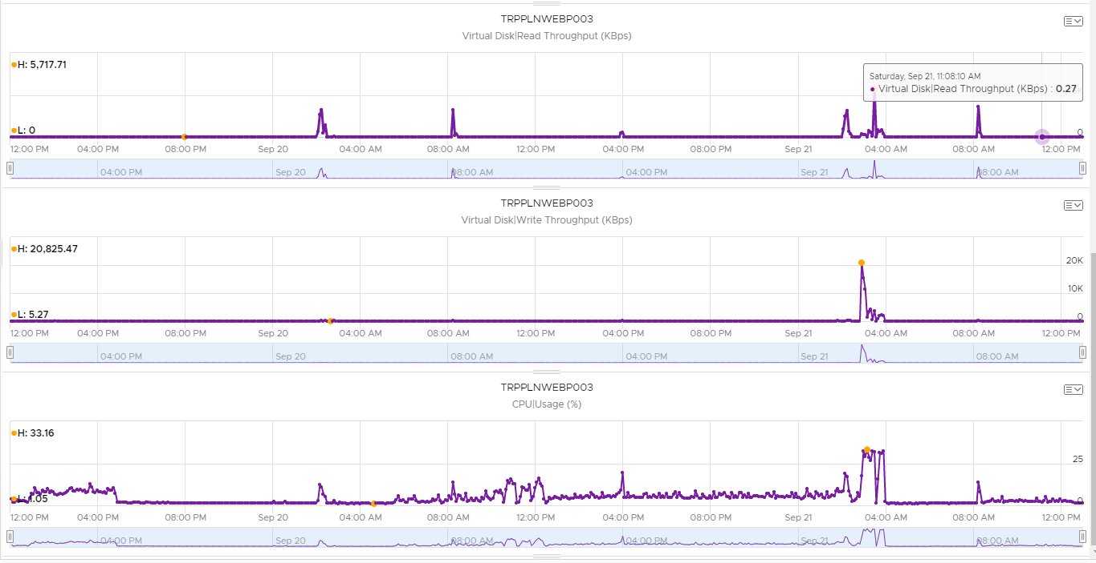

*TRPPLNWEBP004*

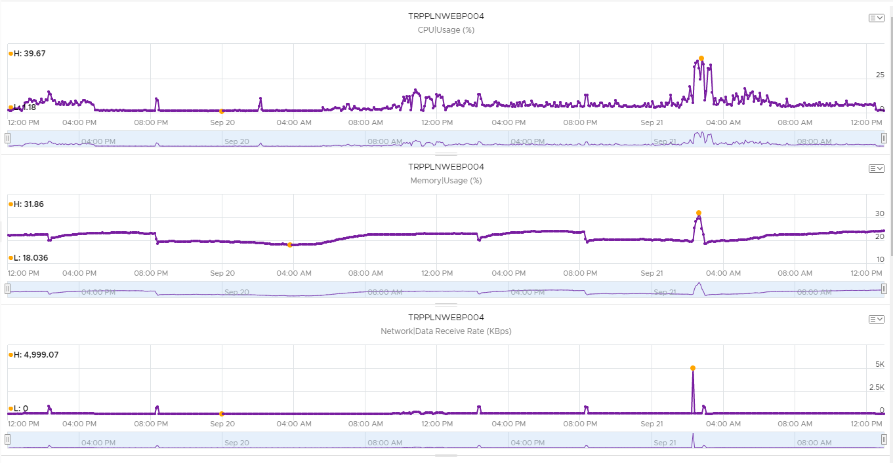

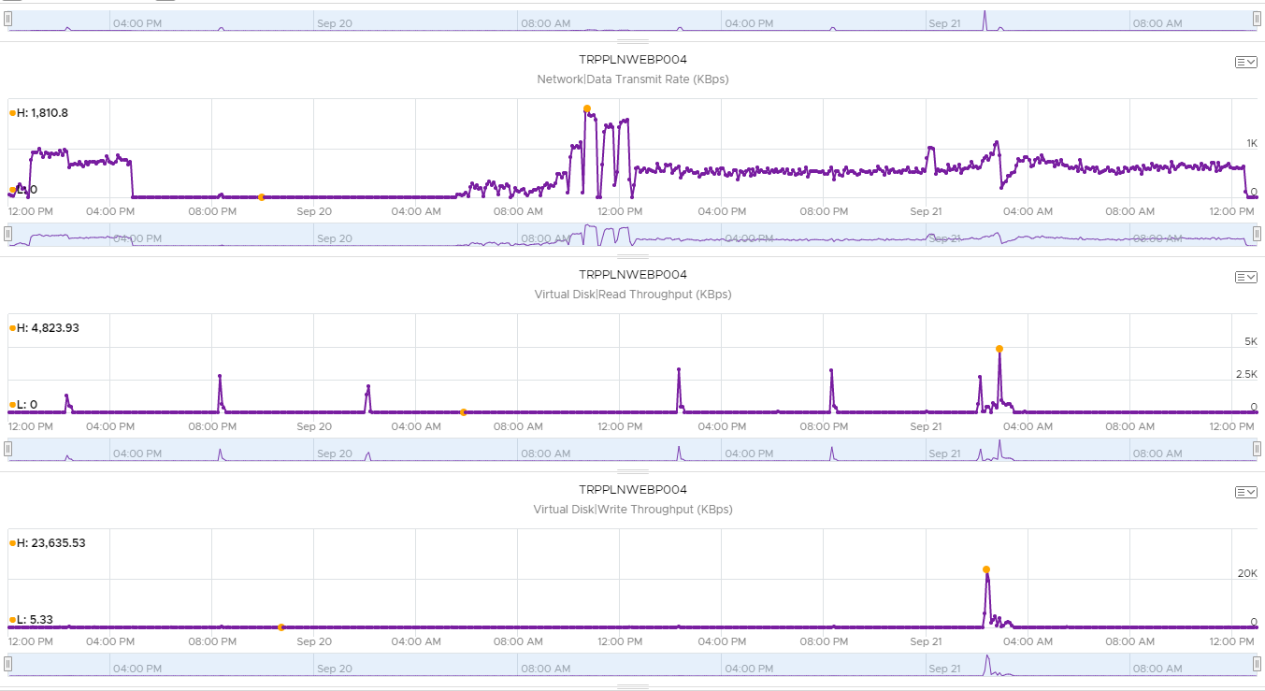

*TRPPLNWEBP005*

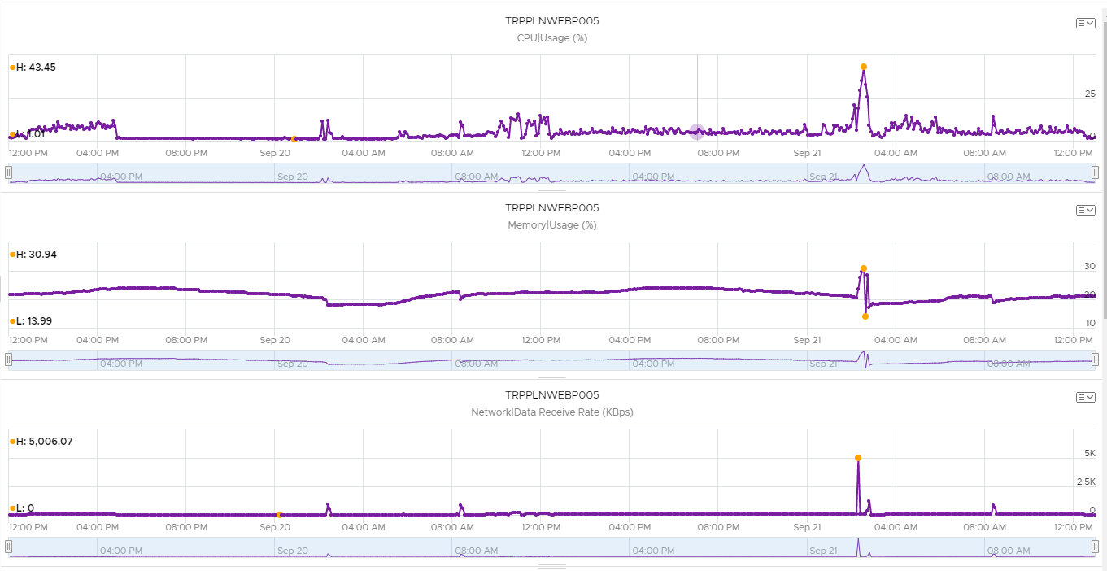

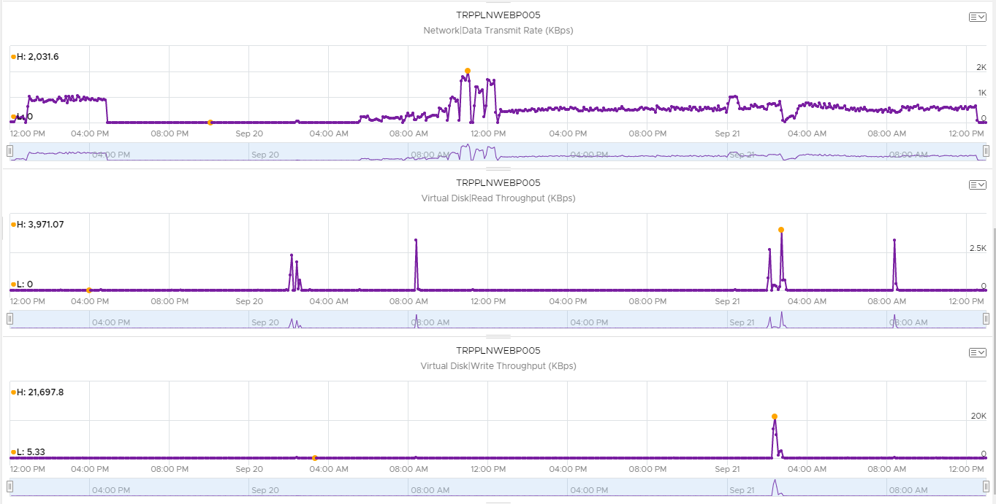

*TRPPLNWEBP006* (006 had brief peaks in memory usage above 50%, but the peaks were short duration)

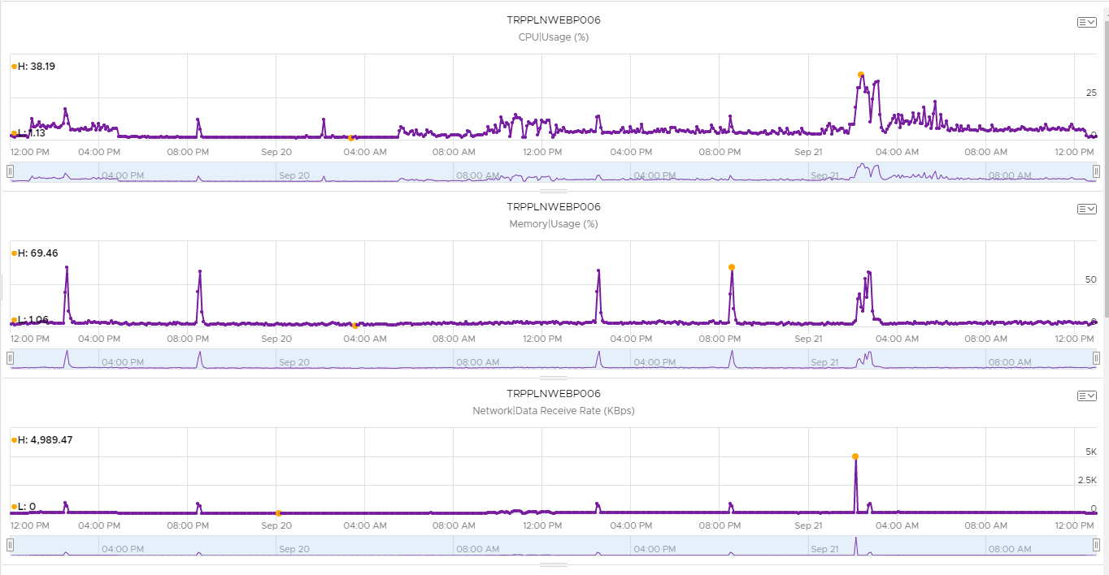

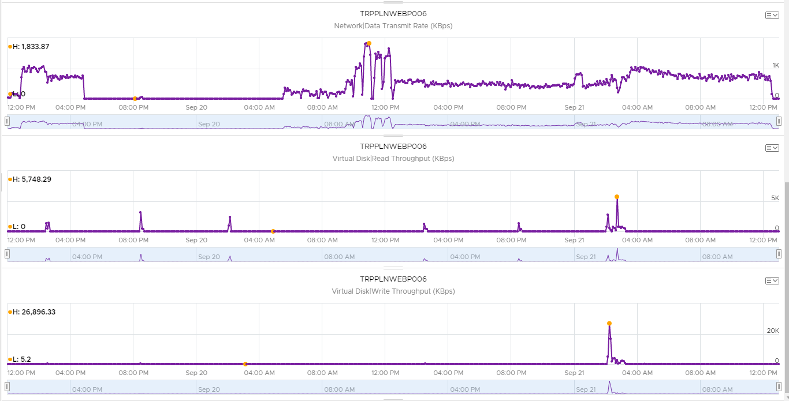

*TRPPLNWEBP007*

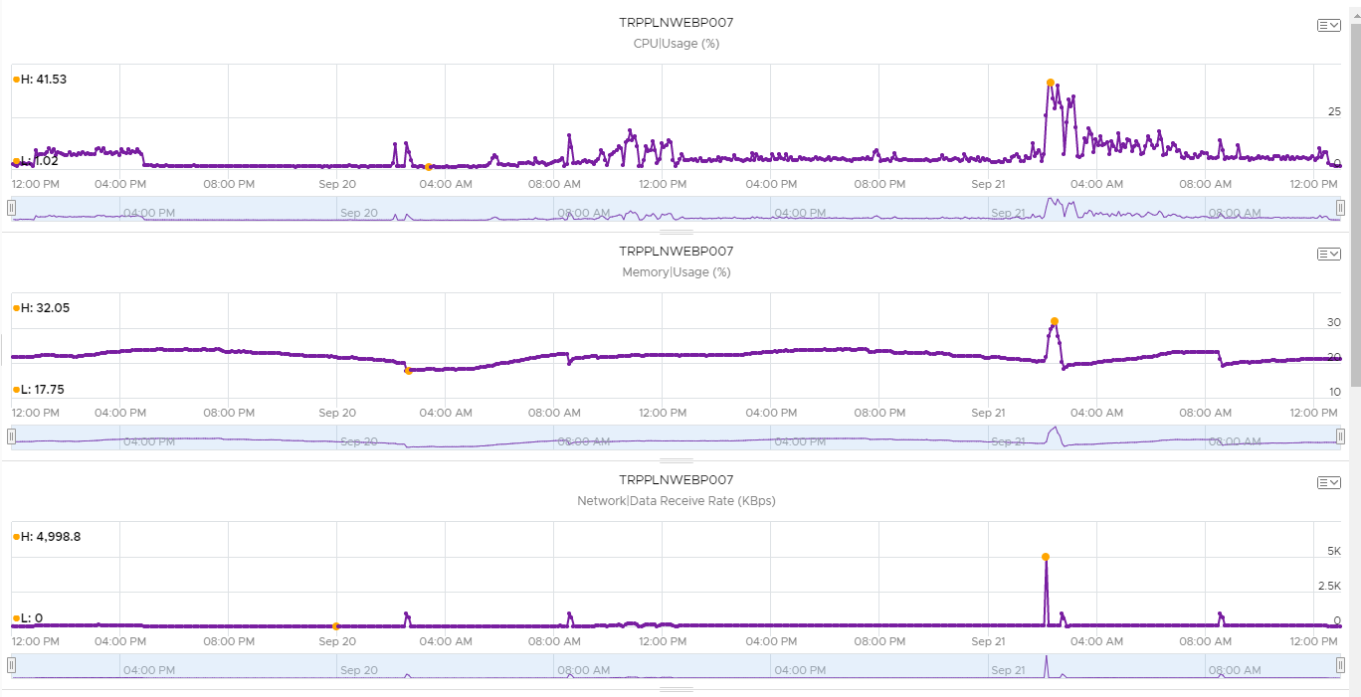

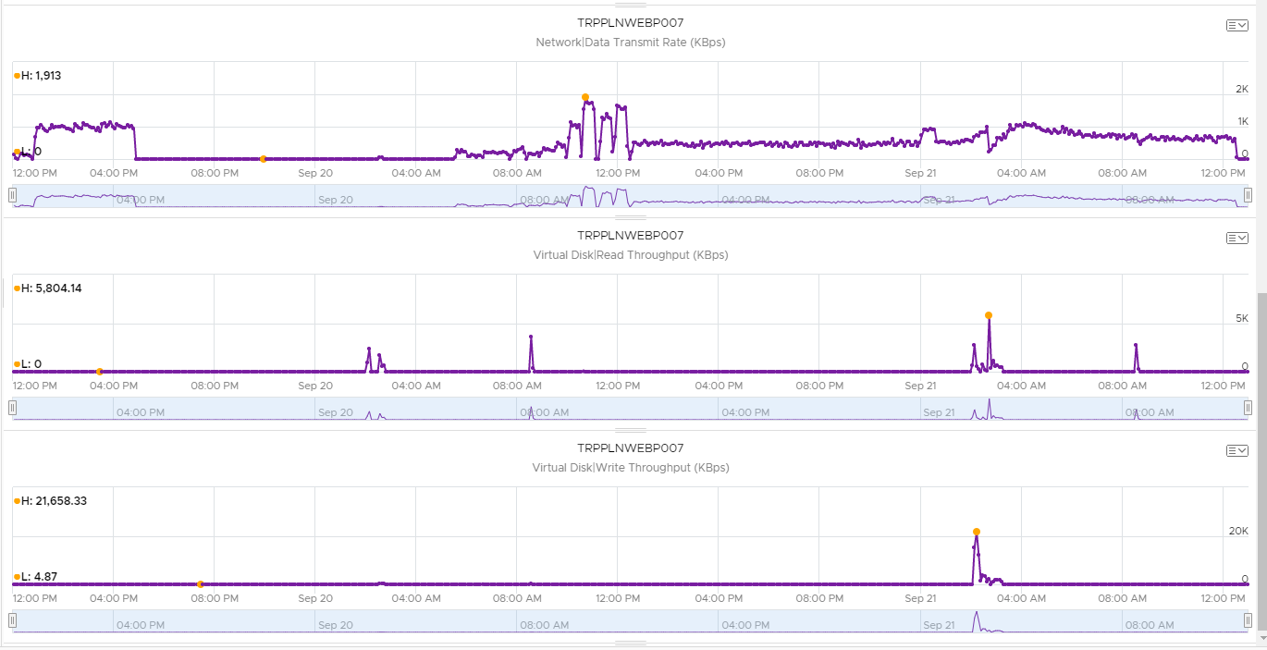

*TRPPLNWEBP008*

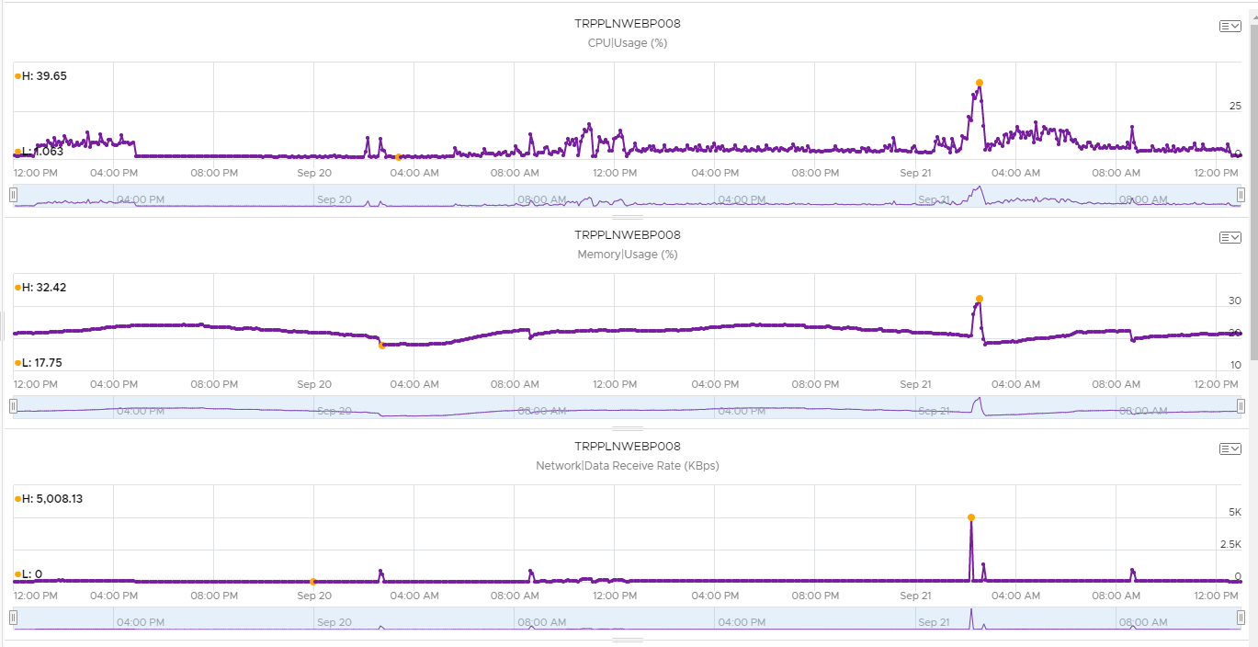

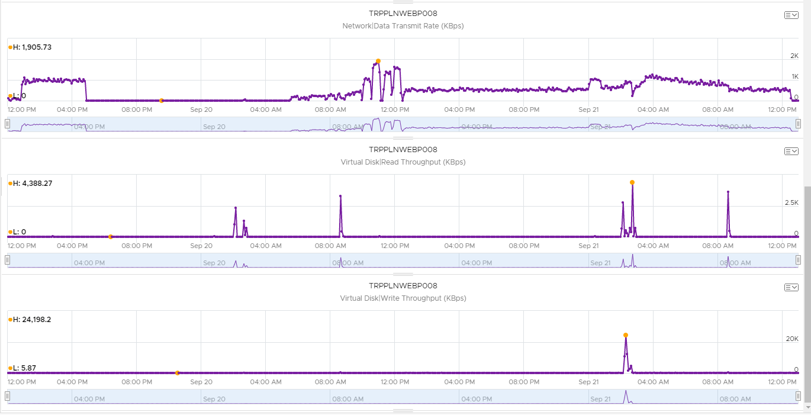

*TRPPLNWEBP009*

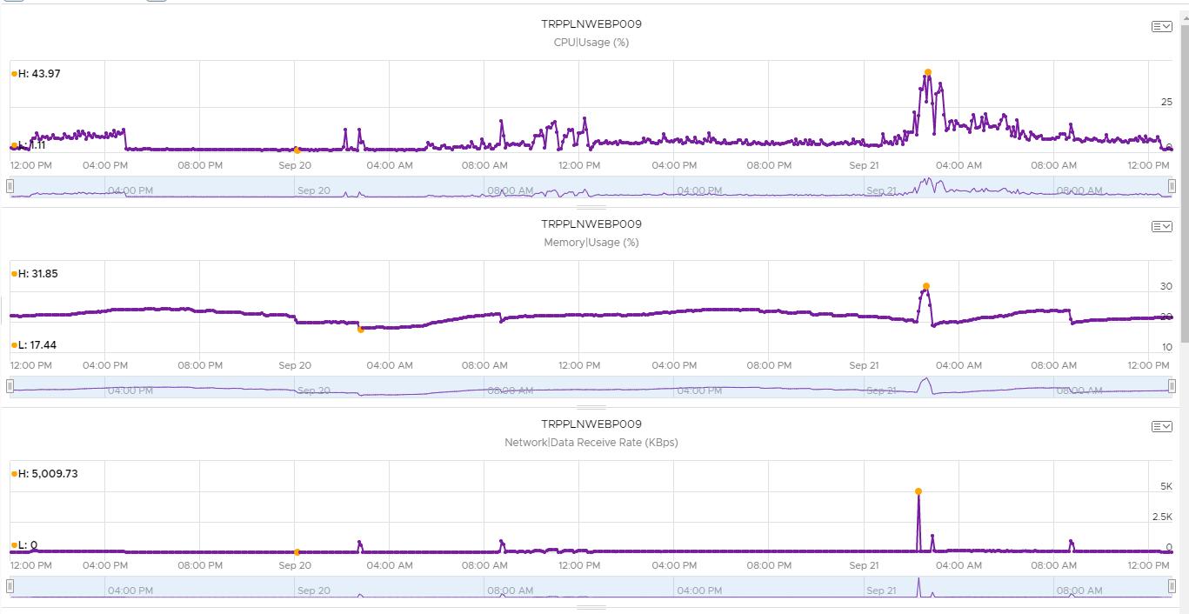

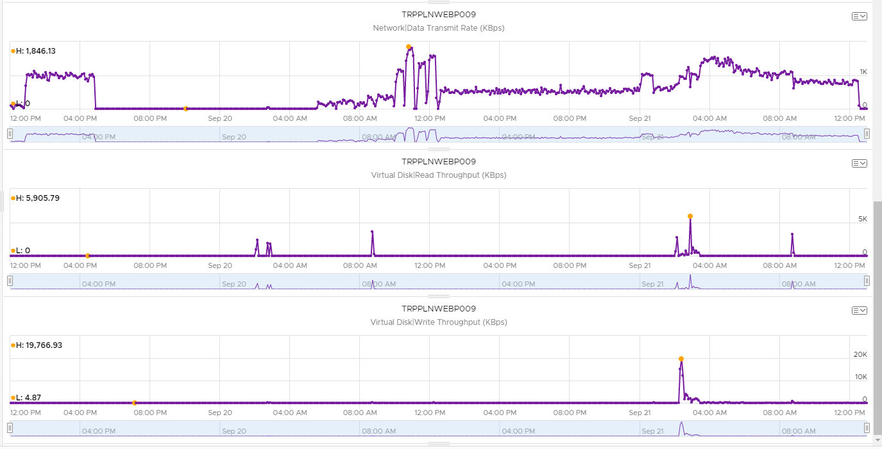

*TRPPLNWEBP010*

